PROJECT REPORT

ON

**PHOTOGRAPHY WEBSITE**

(UNDER THE PARTIAL FULFILLMENT OF THE UNIVERSITY

FOR THE COURSE OF T.Y.BSC

COMPUTER SCIENCE)

**DESIGNED AND DEVELOPED**

BY

**JANHAVI SHARAD SHEDGE**

GUIDED BY

**Dr. Vaishnavi Assar &**

**Ms. Pratiksha Harwalkar**

DEPARTMENT OF COMPUTER SCIENCE

PARLE TILAK VIDYALAYA ASSOCIATION’S

MULUND COLLEGE OF COMMERCE S.N.ROAD,

MULUND (WEST) MUMBAI-80

UNIVERSITY OF MUMBAI

2022-23

**ACKNOWLEDGEMENT**

I have a great pleasure in representing this project report entitled “PHOTOGRAPHY WEBSITE” and I grab this opportunity to convey my immense regards towards all the distinguished people who have their valuable contribution in the hour of need.

I like to extend my gratitude to our beloved Principal Dr. Sonali Pednekar for her timely and prestigious guidance.

I take this opportunity to thank Ms. Reena Shah, Coordinator of the Department and all the faculty members of the Department of Computer Science of Mulund College of Commerce, for giving me an opportunity to complete this project and the most needed guidance throughout the duration of the programme.

I am extremely grateful to my project guides Dr. Vaishnavi Assar & Ms. Pratiksha Harwalkarfor their valuable guidance and necessary support during each phase of the project. She was the source of continuous encouragement as each milestone was crossed.

A special thanks to the University of Mumbai for having prescribed this project work to me as a part of the academic requirement in the Final year of Bachelor of Science in Computer Science.

Finally I also owe to my fellow friends who have been a constant source of help to solve the problems that cropped up during the project development process.

Janhavi Sharad Shedge



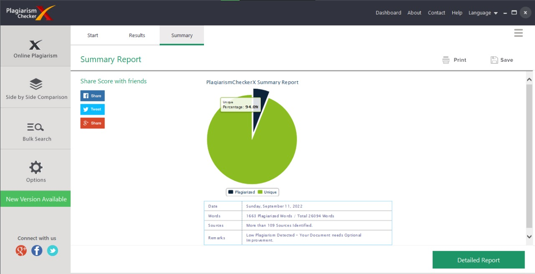

**1.Title**

**PHOTOGRAPHY**

**INDEX**

|  |  |  |
| --- | --- | --- |
| **SR. NO.** | **TOPIC** | **PAGE NO.** |
| 1. | TITLE | 4 |
| 2. | INTRODUCTION | 6 |
| 3. | REQUIREMENT SPECIFICATION | 7 |
| 4. | SYSTEM DESIGN DETAILS | 8 |
| 5. | SYSTEM IMPLEMENTATION | 15 |
| 6. | RESULTS | 80 |
| 7. | CONCLUSION AND FUTURE ENHANCEMENTS | 90 |
| 8. | REFERENCES | 90 |
| 9. | ANNEXURE | 91 |

**2. Introduction**

**2.1 Objective of the project:**

* Clients can easily view the photos,read blogs contact photographer directly by sitting at home.

**2.2 Description of Current System:**

* Simple and Clean UI
* No Ads

**2.3 Limitations of Current System:**

* No option for upload Images and Blog
* Limited Content
* Can’t Save any post
* Like and comment option is missing

.

**2.4 Description of Proposed System:**

* As Photography website is available online client can sit at home and get information about photographer and his work and is more reliable than current system

.**2.5 Advantages of Proposed System:**

* Proposed system reduce time Consumption and client can view all the work done till now by the Photographer easily,view Blogs,Contact the photographer directly and can locate places for shoot.

**3. Requirement Specification**

**3.1 Software Requirement:**

* Operating System - Microsoft Windows 2010
* Application Software - Front end:HTML,CSS,JS

Back end:PHP/SQL

* Platform – VS Editor

**3.2 Hardware Requirement:**

* Processor – 2.10GHz
* RAM – 4GB or more
* Disk Space – 8 GB or less

**3.3 Data Requirement:**

* Username
* Password
* Client Name
* Email Address
* Subject
* Message
* Desired Date
* Desired Location

**3.4 Fact Finding Questions:**

* Why do you need a Photography Website ?
* What are the features that you need in the Photography Website ?
* What is the scope of this system in the future?
* What are the software and hardware requirements of the system?
* Will the system be helpful?

**3. System Design Details**

**4.1: Event Table:**

|  |  |  |  |  |  |  |
| --- | --- | --- | --- | --- | --- | --- |
| **Sr no:** | **Events** | **Trigger** | **Source** | **Activity** | **Response** | **Destination** |
| 1. | Registration | Registration Form | Customers | Create new Account | Adds new account to db | Server |
| 2. | Login | Login Form | Customers | Checks username and password to login | Redirect to Home | Server |
| 3. | Subscribe | SUBSCRIBE | Customers | Enter email id to subscribe | Successfully  subscribe | Server |
| 4. | Know More | Knowmore | Customers | Knowmore helps to read whole information. | Redirects to Information page | Server |
| 5. | Map | Google Map | Customers | Google map help customer to find location | Redirect to google maps | Server |
| 6. | Contact | ContactForm | Customers | Customer can easily contact Photographer | Successful | Server |

**4.2 Class Diagram:**

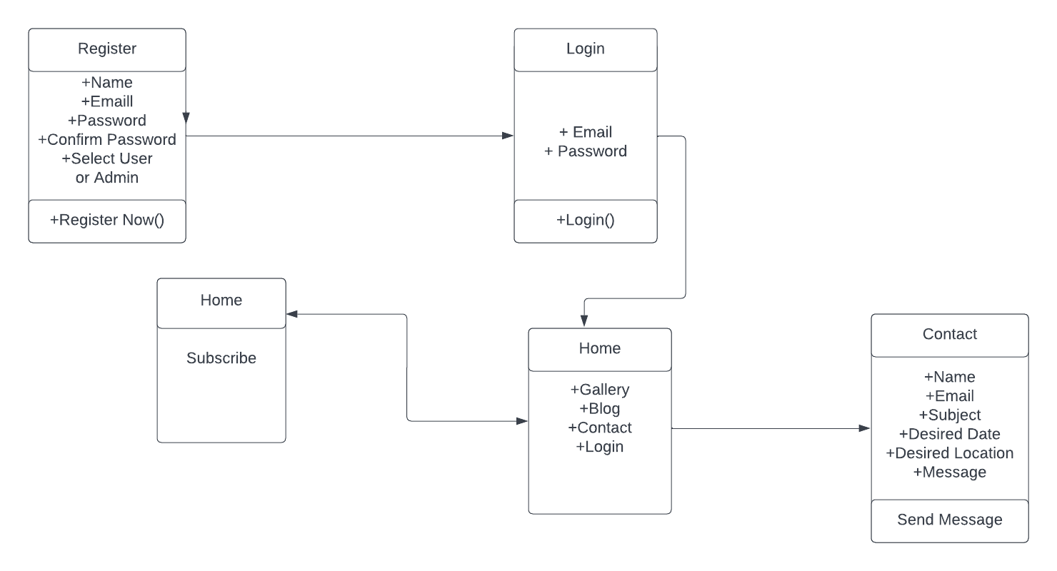

**4.3 Use Case Diagram:**

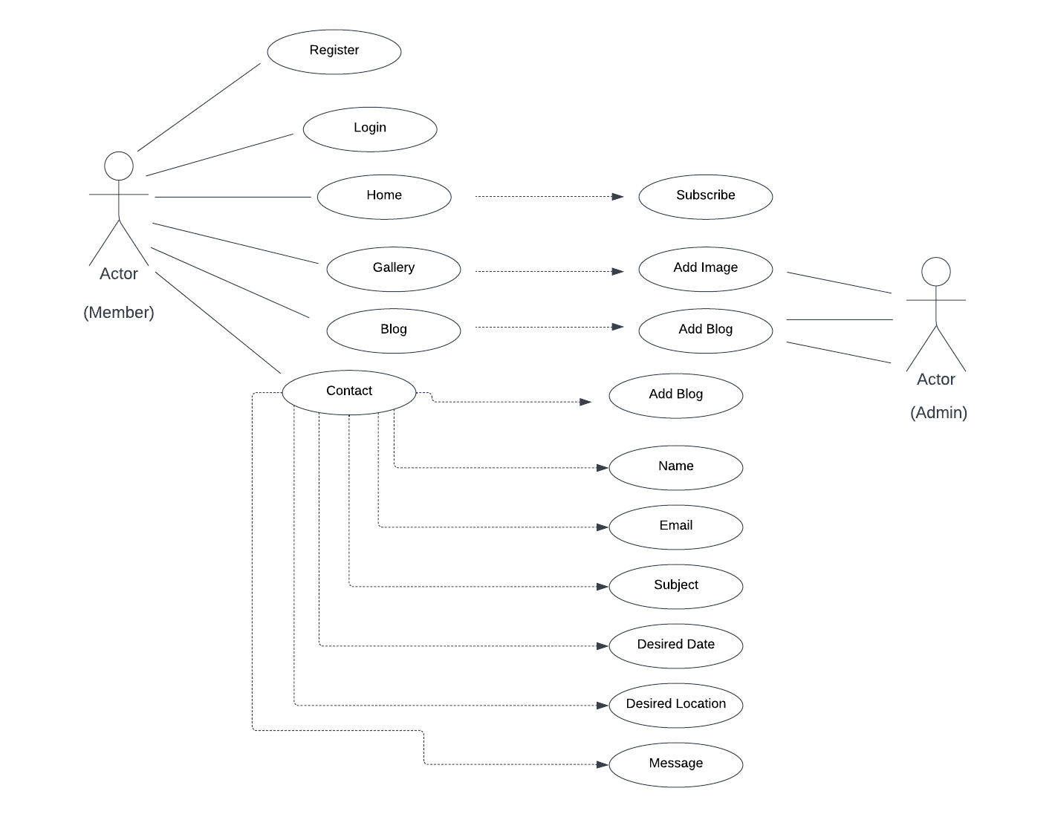

**4.4 Sequence Diagram**

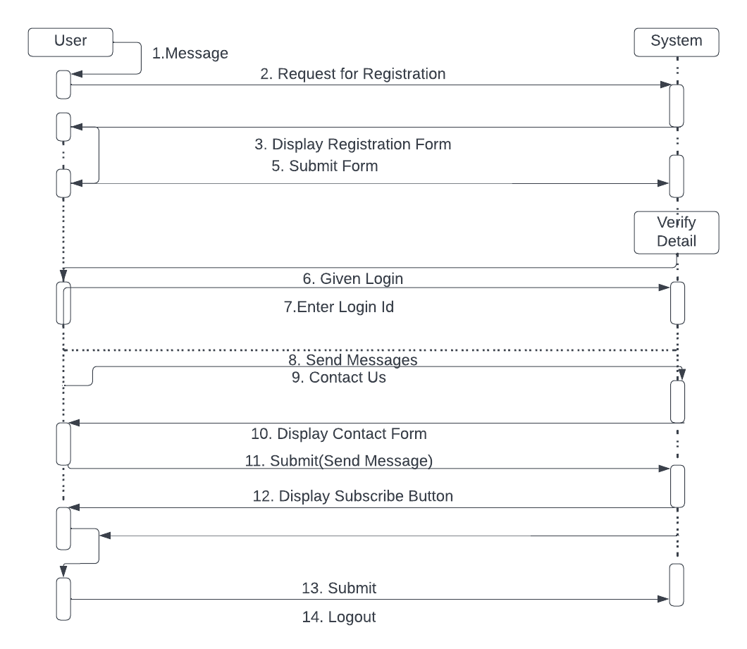

**4.5 Activity Diagram**

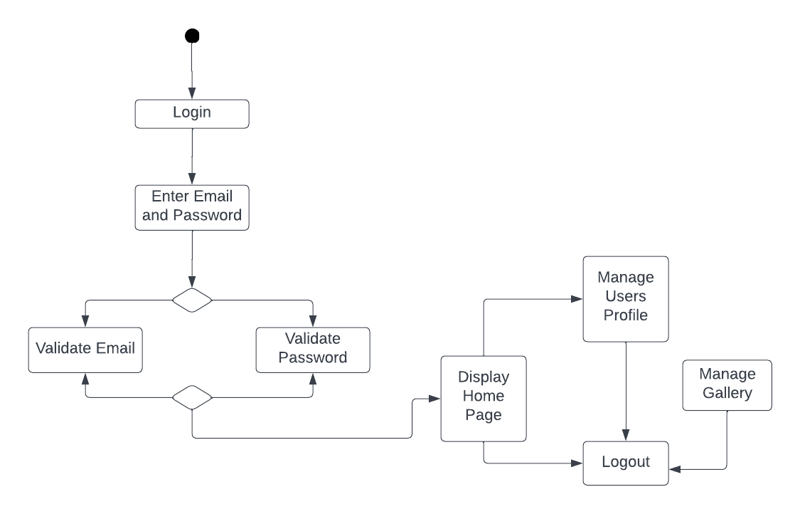

**4.6 State Diagram**

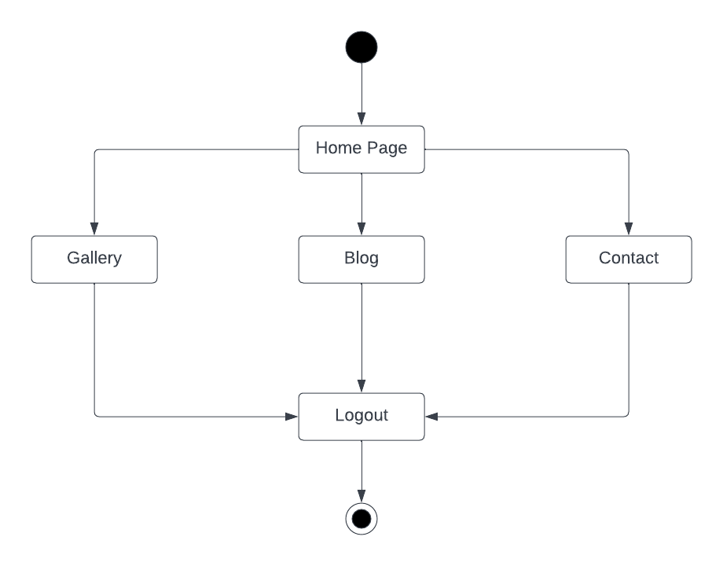

**State Diagram(User Side)**

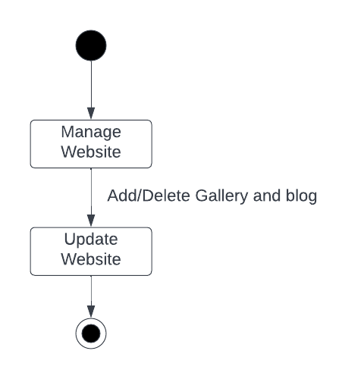

**State Diagram (Admin Side)**

**4.7 Package Diagram**

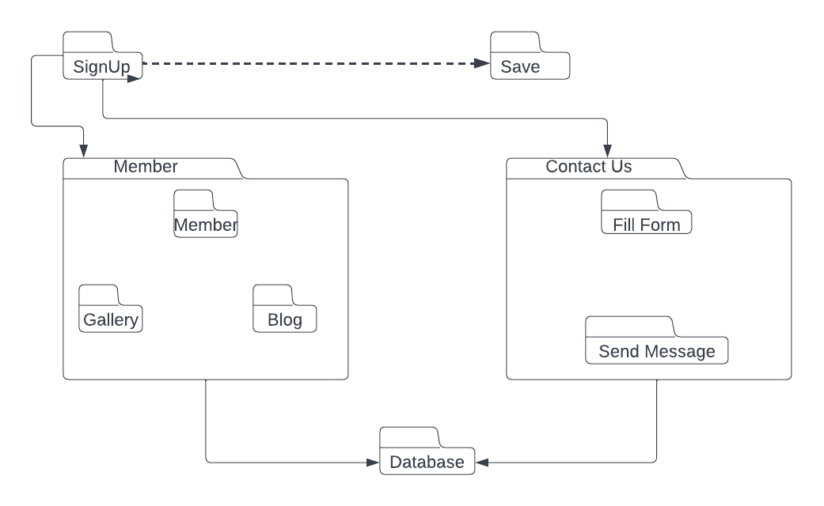

**4.8 Component Diagram**

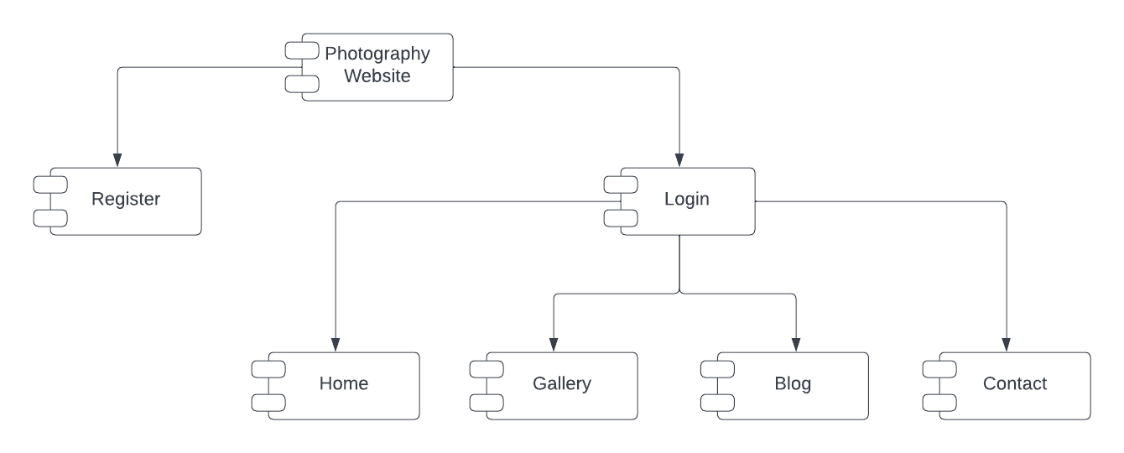

**4.9 Deployment Diagram**

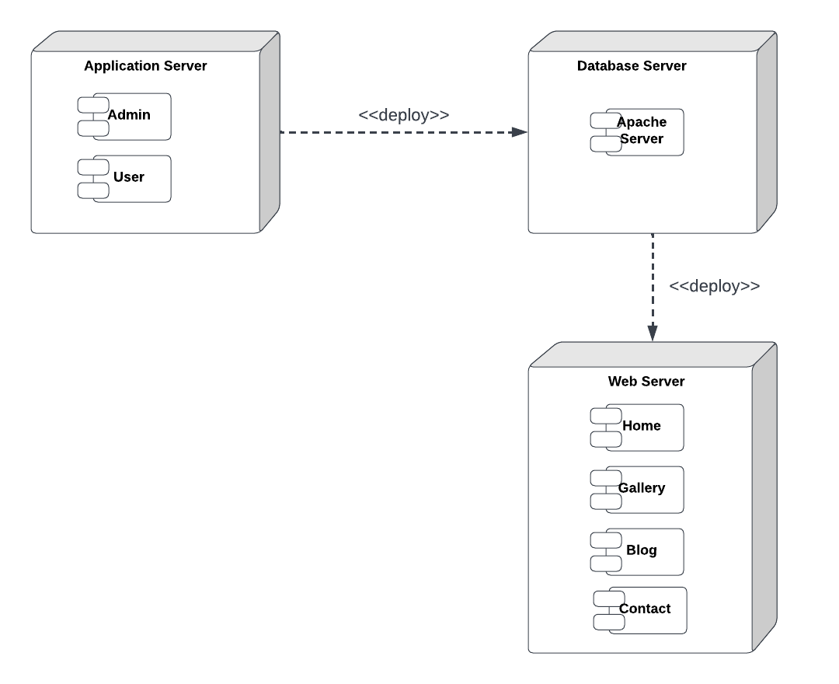

**4.10 Database Design**

**subscribe**

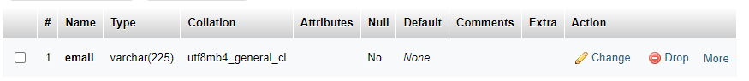

**gallery**

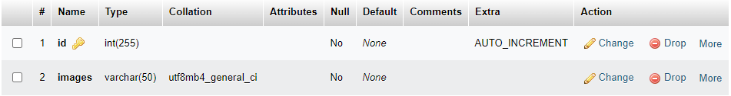

**register**

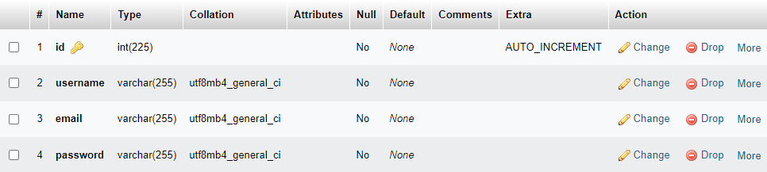

**User_form**

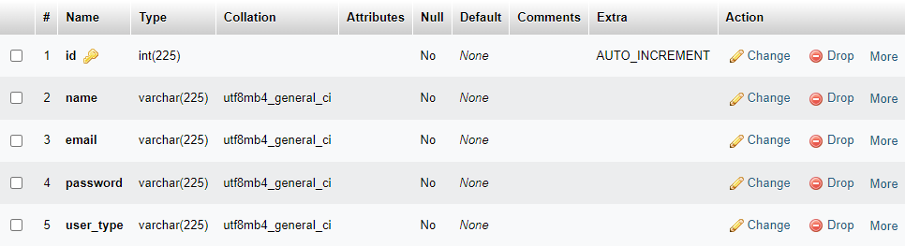

**5. System Implementation**

**Login.php**

<?php

session_start();

    include('includes/header.php');

?>

<div class="container">

<div class="row justify-content-center">

    <div class="col-xl-6 col-lg-12 col-md-6">

        <div class="card o-hidden border-0 shadow-lg my-5">

            <div class="card-body p-0">

                <div class="row">

                    <div class="col-lg-12">

                        <div class="p-5">

                            <div class="text-center">

                                <h1 class="h4 text-gray-900 mb-4">Login Here Admin !</h1>

                                <?php

                                    if(isset($_SESSION['status']) && $_SESSION['status'] !='')

                                    {

                                        echo '<h2 class="bg-danger text-white"> '.$_SESSION['status'].' </h2>';

                                        unset($_SESSION['status']);

                                    }

                                ?>

                            </div>

                            <form class="user" action="code.php" method="POST">

                                <div class="form-group">

                                    <input type="email" name="email" class="form-control form-control-user"

                                        placeholder="Enter Email Address...">

                                </div>

                                <div class="form-group">

                                    <input type="password" name="password" class="form-control form-control-user" placeholder="Password">

                                </div>

                                <button type="submit" name="login_btn" class="btn btn-primary btn-user btn-block">Login</button>

                            </form>

                        </div>

                    </div>

                </div>

            </div>

        </div>

    </div>

</div>

</div>

<?php

    include('includes/scripts.php');

?>

**Register.php**

<?php

include('includes/header.php');

include('includes/navbar.php');

?>

<div class="modal fade" id="addadminprofile" tabindex="-1" role="dialog" aria-labelledby="exampleModalLabel" aria-hidden="true">

  <div class="modal-dialog" role="document">

    <div class="modal-content">

      <div class="modal-header">

        <h5 class="modal-title" id="exampleModalLabel">Add Admin Data</h5>

        <button type="button" class="close" data-dismiss="modal" aria-label="Close">

          <span aria-hidden="true">&times;</span>

        </button>

      </div>

      <form action="code.php" method="POST">

        <div class="modal-body">

            <div class="form-group">

                <label> Username </label>

                <input type="text" name="username" class="form-control" placeholder="Enter Username">

            </div>

            <div class="form-group">

                <label>Email</label>

                <input type="email" name="email" class="form-control checking_email" placeholder="Enter Email">

                <small class="error_email" style="color: red;"></small>

            </div>

            <div class="form-group">

                <label>Password</label>

                <input type="password" name="password" class="form-control" placeholder="Enter Password">

            </div>

            <div class="form-group">

                <label>Confirm Password</label>

                <input type="password" name="confirmpassword" class="form-control" placeholder="Confirm Password">

            </div>

        </div>

        <div class="modal-footer">

            <button type="button" class="btn btn-secondary" data-dismiss="modal">Close</button>

            <button type="submit" name="registerbtn" class="btn btn-primary">Save</button>

        </div>

      </form>

    </div>

  </div>

</div>

<button type="button" class="btn btn-primary" data-toggle="modal" data-target="#addadminprofile">

       Add Admin Profile

</button>

</h6>

</div>

<div class="card-body">

    <div class="table-responsive">

    <table class="table table-bordered" id="dataTable" width="100%" cellspacing="0">

        <thead>

            <tr>

                <th>Name</th>

                <th>Position</th>

                <th>Office</th>

                <th>Age</th>

                <th>Start Date</th>

                <th>Salary</th>

            </tr>

        </thead>

        <tbody>

            <tr>

                <td></td>

                <td></td>

                <td></td>

                <td></td>

                <td></td>

                <td></td>

            </tr>

        </tbody>

        </table>

    </div>

  </div>

</div>

<?php

include('includes/scripts.php');

include('includes/footer.php');

?>

**Logout.php**

<?php

session_start();

if(isset($_POST['logout_btn']))

{

    session_destroy();

    unset($_SESSION['username']);

    header('Location: login.php');

}

?>

**Header.php**

<!DOCTYPE html>

<html lang="en">

<head>

    <meta charset="utf-8">

    <meta http-equiv="X-UA-Compatible" content="IE=edge">

    <meta name="viewport" content="width=device-width, initial-scale=1, shrink-to-fit=no">

    <meta name="description" content="">

    <meta name="author" content="">

    <title>SB Admin 2 - Dashboard</title>

    <link href="vendor/fontawesome-free/css/all.min.css" rel="stylesheet" type="text/css">

    <link

        href="https://fonts.googleapis.com/css?family=Nunito:200,200i,300,300i,400,400i,600,600i,700,700i,800,800i,900,900i"

        rel="stylesheet">

    <

    <link href="css/sb-admin-2.min.css" rel="stylesheet">

</head>

<body id="page-top">

    <div id="wrapper">

**Footer.php**

 <footer class="sticky-footer bg-white">

                <div class="container my-auto">

                    <div class="copyright text-center my-auto">

                        <span>Copyright &copy; Your Website 2021</span>

                    </div>

                </div>

            </footer>

        </div>

</body>

</html>

**navbar.php**

<ul class="navbar-nav bg-gradient-primary sidebar sidebar-dark accordion" id="accordionSidebar">

<a class="sidebar-brand d-flex align-items-center justify-content-center" href="index.php">

    <div class="sidebar-brand-icon rotate-n-15">

    </div>

    <div class="sidebar-brand-text mx-3">Admin Page </div>

</a>

<hr class="sidebar-divider my-0">

<li class="nav-item active">

    <a class="nav-link" href="index.php">

        <i class="fas fa-fw fa-tachometer-alt"></i>

        <span>Dashboard</span></a>

</li>

<hr class="sidebar-divider">

<li class="nav-item">

    <a class="nav-link collapsed" href="#" data-toggle="collapse" data-target="#collapseTwo"

        aria-expanded="true" aria-controls="collapseTwo">

        <i class="fas fa-fw fa-cog"></i>

        <span>Admin Details</span>

    </a>

    <div id="collapseTwo" class="collapse" aria-labelledby="headingTwo" data-parent="#accordionSidebar">

        <div class="bg-white py-2 collapse-inner rounded">

            <h6 class="collapse-header">Admin details</h6>

            <a class="collapse-item" href="register.php">Login Details</a>

        </div>

    </div>

</li>

<hr class="sidebar-divider">

<div class="sidebar-heading">

    Photos

</div>

<li class="nav-item">

    <a class="nav-link" href="blog.php">

        <i class="fas fa-fw fa-chart-area"></i>

        <span>Blog</span></a>

</li>

<li class="nav-item">

    <a class="nav-link" href="gallery.php">

        <i class="fas fa-fw fa-table"></i>

        <span>Gallery</span></a>

</li>

<li class="nav-item">

    <a class="nav-link" href="subscribe_data.php">

        <i class="fas fa-fw fa-table"></i>

        <span>Subscribe</span></a>

</li>

<li class="nav-item">

    <a class="nav-link" href="Contact.php">

        <i class="fas fa-fw fa-table"></i>

        <span>Contact</span></a>

</li>

            <hr class="sidebar-divider">

<li class="nav-item">

    <a class="nav-link collapsed" href="#" data-toggle="collapse" data-target="#collapsePages"

        aria-expanded="true" aria-controls="collapsePages">

        <i class="fas fa-fw fa-folder"></i>

        <span>Other</span>

    </a>

    <div id="collapsePages" class="collapse" aria-labelledby="headingPages" data-parent="#accordionSidebar">

        <div class="bg-white py-2 collapse-inner rounded">

            <a class="collapse-item" href="login.php">Logout</a>

            <a class="collapse-item" href="index.php">Home</a>

        </div>

    </div>

</li>

<hr class="sidebar-divider d-none d-md-block">

<div class="text-center d-none d-md-inline">

    <button class="rounded-circle border-0" id="sidebarToggle"></button>

</div>

</ul>

<a class="scroll-to-top rounded" href="#page-top">

<i class="fas fa-angle-up"></i>

</a>

<div class="modal fade" id="logoutModal" tabindex="-1" role="dialog" aria-labelledby="exampleModalLabel"

aria-hidden="true">

<div class="modal-dialog" role="document">

<div class="modal-content">

    <div class="modal-header">

        <h5 class="modal-title" id="exampleModalLabel">Ready to Leave?</h5>

        <button class="close" type="button" data-dismiss="modal" aria-label="Close">

            <span aria-hidden="true">×</span>

        </button>

    </div>

    <div class="modal-body">Select "Logout" below if you are ready to end your current session.</div>

    <div class="modal-footer">

        <button class="btn btn-secondary" type="button" data-dismiss="modal">Cancel</button>

        <form action="logout.php" method="POST">

          <button type="submit" name="logout_btn" class="btn btn-primary">Logout</button>

    </form>

    </div>

</div>

</div>

</div>

<div id="content-wrapper" class="d-flex flex-column">

<div id="content">

    <nav class="navbar navbar-expand navbar-light bg-white topbar mb-4 static-top shadow">

        <button id="sidebarToggleTop" class="btn btn-link d-md-none rounded-circle mr-3">

            <i class="fa fa-bars"></i>

        </button>

        <form

            class="d-none d-sm-inline-block form-inline mr-auto ml-md-3 my-2 my-md-0 mw-100 navbar-search">

            <div class="input-group">

                <input type="text" class="form-control bg-light border-0 small" placeholder="Search for..."

                    aria-label="Search" aria-describedby="basic-addon2">

                <div class="input-group-append">

                    <button class="btn btn-primary" type="button">

                        <i class="fas fa-search fa-sm"></i>

                    </button>

                </div>

            </div>

        </form>

        <ul class="navbar-nav ml-auto">

            <li class="nav-item dropdown no-arrow d-sm-none">

                <a class="nav-link dropdown-toggle" href="#" id="searchDropdown" role="button"

                    data-toggle="dropdown" aria-haspopup="true" aria-expanded="false">

                    <i class="fas fa-search fa-fw"></i>

                </a>

                <div class="dropdown-menu dropdown-menu-right p-3 shadow animated--grow-in"

                    aria-labelledby="searchDropdown">

                    <form class="form-inline mr-auto w-100 navbar-search">

                        <div class="input-group">

                            <input type="text" class="form-control bg-light border-0 small"

                                placeholder="Search for..." aria-label="Search"

                                aria-describedby="basic-addon2">

                            <div class="input-group-append">

                                <button class="btn btn-primary" type="button">

                                    <i class="fas fa-search fa-sm"></i>

                                </button>

                            </div>

                        </div>

                    </form>

                </div>

            </li>

            <li class="nav-item dropdown no-arrow mx-1">

                <a class="nav-link dropdown-toggle" href="#" id="alertsDropdown" role="button"

                    data-toggle="dropdown" aria-haspopup="true" aria-expanded="false">

                    <i class="fas fa-bell fa-fw"></i>

                    <span class="badge badge-danger badge-counter">3+</span>

                </a>

                <div class="dropdown-list dropdown-menu dropdown-menu-right shadow animated--grow-in"

                    aria-labelledby="alertsDropdown">

                    <h6 class="dropdown-header">

                        Alerts Center

                    </h6>

                    <a class="dropdown-item d-flex align-items-center" href="#">

                        <div class="mr-3">

                            <div class="icon-circle bg-primary">

                                <i class="fas fa-file-alt text-white"></i>

                            </div>

                        </div>

                        <div>

                            <div class="small text-gray-500">December 12, 2019</div>

                            <span class="font-weight-bold">A new monthly report is ready to download!</span>

                        </div>

                    </a>

                    <a class="dropdown-item d-flex align-items-center" href="#">

                        <div class="mr-3">

                            <div class="icon-circle bg-success">

                                <i class="fas fa-donate text-white"></i>

                            </div>

                        </div>

                        <div>

                            <div class="small text-gray-500">December 7, 2019</div>

                            $290.29 has been deposited into your account!

                        </div>

                    </a>

                    <a class="dropdown-item d-flex align-items-center" href="#">

                        <div class="mr-3">

                            <div class="icon-circle bg-warning">

                                <i class="fas fa-exclamation-triangle text-white"></i>

                            </div>

                        </div>

                        <div>

                            <div class="small text-gray-500">December 2, 2019</div>

                            Spending Alert: We've noticed unusually high spending for your account.

                        </div>

                    </a>

                    <a class="dropdown-item text-center small text-gray-500" href="#">Show All Alerts</a>

                </div>

            </li>

            <li class="nav-item dropdown no-arrow mx-1">

                <a class="nav-link dropdown-toggle" href="#" id="messagesDropdown" role="button"

                    data-toggle="dropdown" aria-haspopup="true" aria-expanded="false">

                    <i class="fas fa-envelope fa-fw"></i>

                    <span class="badge badge-danger badge-counter">7</span>

                </a>

                <div class="dropdown-list dropdown-menu dropdown-menu-right shadow animated--grow-in"

                    aria-labelledby="messagesDropdown">

                    <h6 class="dropdown-header">

                        Message Center

                    </h6>

                    <a class="dropdown-item d-flex align-items-center" href="#">

                        <div class="dropdown-list-image mr-3">

                            <img class="rounded-circle" src="img/undraw_profile_1.svg"

                                alt="...">

                            <div class="status-indicator bg-success"></div>

                        </div>

                        <div class="font-weight-bold">

                            <div class="text-truncate">Hi there! I am wondering if you can help me with a

                                problem I've been having.</div>

                            <div class="small text-gray-500">Emily Fowler · 58m</div>

                        </div>

                    </a>

                    <a class="dropdown-item d-flex align-items-center" href="#">

                        <div class="dropdown-list-image mr-3">

                            <img class="rounded-circle" src="img/undraw_profile_2.svg"

                                alt="...">

                            <div class="status-indicator"></div>

                        </div>

                        <div>

                            <div class="text-truncate">I have the photos that you ordered last month, how

                                would you like them sent to you?</div>

                            <div class="small text-gray-500">Jae Chun · 1d</div>

                        </div>

                    </a>

                    <a class="dropdown-item d-flex align-items-center" href="#">

                        <div class="dropdown-list-image mr-3">

                            <img class="rounded-circle" src="img/undraw_profile_3.svg"

                                alt="...">

                            <div class="status-indicator bg-warning"></div>

                        </div>

                        <div>

                            <div class="text-truncate">Last month's report looks great, I am very happy with

                                the progress so far, keep up the good work!</div>

                            <div class="small text-gray-500">Morgan Alvarez · 2d</div>

                        </div>

                    </a>

                    <a class="dropdown-item d-flex align-items-center" href="#">

                        <div class="dropdown-list-image mr-3">

                            <img class="rounded-circle" src="https://source.unsplash.com/Mv9hjnEUHR4/60x60"

                                alt="...">

                            <div class="status-indicator bg-success"></div>

                        </div>

                        <div>

                            <div class="text-truncate">Am I a good boy? The reason I ask is because someone

                                told me that people say this to all dogs, even if they aren't good...</div>

                            <div class="small text-gray-500">Chicken the Dog · 2w</div>

                        </div>

                    </a>

                    <a class="dropdown-item text-center small text-gray-500" href="#">Read More Messages</a>

                </div>

            </li>

            <div class="topbar-divider d-none d-sm-block"></div>

            <li class="nav-item dropdown no-arrow">

                <a class="nav-link dropdown-toggle" href="#" id="userDropdown" role="button"

                    data-toggle="dropdown" aria-haspopup="true" aria-expanded="false">

                    <span class="mr-2 d-none d-lg-inline text-gray-600 small">

                        <!-- <?php echo $_SESSION['username'] ?> -->

                    </span>

                    <img class="img-profile rounded-circle"

                        src="img/undraw_profile.svg">

                </a>

                <div class="dropdown-menu dropdown-menu-right shadow animated--grow-in"

                    aria-labelledby="userDropdown">

                    <div class="dropdown-divider"></div>

                    <a class="dropdown-item" href="#" data-toggle="modal" data-target="#logoutModal">

                        <i class="fas fa-sign-out-alt fa-sm fa-fw mr-2 text-gray-400"></i>

                        Logout

                    </a>

                </div>

            </li>

        </ul>

    </nav>

    <!-- End of Topbar -->

**scripts.php**

    <script src="vendor/jquery/jquery.min.js"></script>

    <script src="vendor/bootstrap/js/bootstrap.bundle.min.js"></script>

       <script src="vendor/jquery-easing/jquery.easing.min.js"></script>

       <script src="js/sb-admin-2.min.js"></script>

    <script src="vendor/chart.js/Chart.min.js"></script>

    <script src="js/sweetalert.min.js"></script>

<?php

    if(isset($_SESSION['status']) && $_SESSION['status'] !='')

    {

        ?>

            <script>

            swal({

                title: "<?php echo $_SESSION['status']; ?>",

                //text: "You clicked the button!",

                icon: "<?php echo $_SESSION['status_code']; ?>",

                button: "Aww yiss!",

                });

        </script>

        <?php

          unset($_SESSION['status']);

    }

?>

    <script src="js/demo/chart-area-demo.js"></script>

    <script src="js/demo/chart-pie-demo.js"></script>

**code.php**

<?php

if(isset($_POST['save_gallery']))

{

    $connection=mysqli_connect("localhost:3307","root","123456","photography");

    $images = $_FILES['gallery_image']['name'];

     $query="INSERT INTO gallery(`images`) VALUES('$images')";

     $query_run=mysqli_query($connection,$query);

     if($query_run)

     {

        move_uploaded_file($_FILES["gallery_image"]["tmp_name"],"upload/".$_FILES["file"]["id"]);

        $_SESSION['status']='gallery added';

        $_SESSION['status_code'] = "success";

        header('Location:gallery.php');

     }

     else

     {

        $_SESSION['status']='gallery not added';

        header('Location:gallery.php');

     }

    }

if(isset($_POST['gallery_update_btn']))

{

    $edit_gallery_id = $_POST['edit_gallery_id'];

    $gallery_img = $_FILES["gallery_img"]['name'];

    $connection=mysqli_connect("localhost:3307","root","123456","photography");

    $query = "UPDATE gallery SET name ='$images='$gallery_img' WHERE id='$edit_gallery_id'";

    $query_run = mysqli_query($connection,$query);

    if($query_run)

        {

            if($gallery_img == NULL){

               $_SESSION['status'] = " Product Updated with existing image";

               $_SESSION['status_code'] = "success";

                header('Location:gallery.php');

            }

            else{

                move_uploaded_file($_FILES["gallery_img"]["tmp_name"],"upload/".$_FILES["gallery_img"]["name"]);

                $_SESSION['status'] = " gallery Updated";

                $_SESSION['status_code'] = "success";

                header('Location:gallery.php');

            }

        }

    }

    else{

            $_SESSION['status'] = "gallery Not Updated";

            $_SESSION['status_code'] = "error";

            header('Location:gallery.php');

        }

$connection=mysqli_connect("localhost:3307","root","123456","photography");

if(isset($_POST['gallery_delete_btn']))

{

    $id= $_POST['gallery_delete_id'];

    $query="DELETE FROM gallery WHERE id='$id' ";

    $query_run =mysqli_query($connection,$query);

    if($query_run)

    {

        $_SESSION['success']= "product data is deleted";

        header("Location:gallery.php");

    }

    else{

        $_SESSION['status']= "product data is not deleted";

        header("Location:gallery.php");

    }

}

?>

<?php

$connection=mysqli_connect("localhost:3307","root","123456","photography");

if(isset($_POST['registerbtn']))

{

    $username = $_POST['username'];

    $email = $_POST['email'];

    $password = $_POST['password'];

    $cpassword = $_POST['confirmpassword'];

    $email_query = "SELECT * FROM register WHERE email='$email' ";

    $email_query_run = mysqli_query($connection, $email_query);

    if(mysqli_num_rows($email_query_run) > 0)

    {

        $_SESSION['status'] = "Email Already Taken. Please Try Another one.";

        $_SESSION['status_code'] = "error";

        header('Location: register.php');

    }

    else

    {

        if(strlen($password) >= 6){

            if($password === $cpassword)

        {

            $query = "INSERT INTO register (username,email,password) VALUES ('$username','$email','$password')";

            $query_run = mysqli_query($connection, $query);

            if($query_run)

            {

                // echo "Saved";

                $_SESSION['status'] = "Admin Profile Added";

                $_SESSION['status_code'] = "success";

                header('Location: register.php');

            }

            else

            {

                $_SESSION['status'] = "Admin Profile Not Added";

                $_SESSION['status_code'] = "error";

                header('Location: register.php');

            }

        }

        else

        {

            $_SESSION['status'] = "Password and Confirm Password Does Not Match";

            $_SESSION['status_code'] = "warning";

            header('Location: register.php');

        }

        }

        else{

            $_SESSION['status'] = "Password length less than 6 characters";

            $_SESSION['status_code'] = "warning";

            header('Location: register.php');

        }

    }

}

if(isset($_POST['updatebtn']))

{

    $id = $_POST['edit_id'];

    $username = $_POST['edit_username'];

    $email = $_POST['edit_email'];

    $password = $_POST['edit_password'];

    $usertypeupdate = $_POST['update_usertype'];

    $query = "UPDATE register SET username='$username', email='$email', password='$password' WHERE id='$id' ";

    $query_run = mysqli_query($connection, $query);

    if($query_run)

    {

        $_SESSION['status'] = "Your Data is Updated";

        $_SESSION['status_code'] = "success";

        header('Location: register.php');

    }

    else

    {

        $_SESSION['status'] = "Your Data is NOT Updated";

        $_SESSION['status_code'] = "error";

        header('Location: register.php');

    }

}

if(isset($_POST['delete_btn']))

{

    $id = $_POST['delete_id'];

    $query = "DELETE FROM register WHERE id='$id' ";

    $query_run = mysqli_query($connection, $query);

    if($query_run)

    {

        $_SESSION['status'] = "Your Data is Deleted";

        $_SESSION['status_code'] = "success";

        header('Location: register.php');

    }

    else

    {

        $_SESSION['status'] = "Your Data is NOT DELETED";

        $_SESSION['status_code'] = "error";

        header('Location: register.php');

    }

}

if(isset($_POST['login_btn']))

{

    $email_login = $_POST['email'];

    $password_login = $_POST['password'];

    $query = "SELECT * FROM register WHERE email='$email_login' AND password='$password_login' LIMIT 1";

    $query_run = mysqli_query($connection, $query);

   if(mysqli_fetch_array($query_run))

   {

        $_SESSION['username'] = $email_login;

        $_SESSION['status_code'] = "success";

        header('Location: index.php');

   }

   else

   {

        $_SESSION['status'] = "Email / Password is Invalid";

        $_SESSION['status_code'] = "error";

        header('Location: login.php');

   }

}

?>

**dbconfig.php**

<?php

$server_name = "localhost:3307";

$db_username = "root";

$db_password = "123456";

$db_name = "photography";

$connection = mysqli_connect($server_name,$db_username,$db_password,$db_name);

$dbconfig = mysqli_select_db($connection,$db_name);

if($dbconfig){

    //echo "Database Connected";

}else{

    echo '

        <div class="container">

            <div class="row">

                <div class="col-md-8 mr-auto ml-auto text-center py-5 mt-5">

                    <div class="card">

                        <div class="card-body">

                            <h1 class="card-title bg-danger text-white"> Database Connection Failed </h1>

                            <h2 class="card-title"> Database Failure</h2>

                            <p class="card-text"> Please Check Your Database Connection.</p>

                            <a href="#" class="btn btn-primary">:( </a>

                        </div>

                    </div>

                </div>

            </div>

        </div>

    ';

}

?>

**gallery.php**

<?php

session_start();

 include('includes/header.php');

 include('includes/navbar.php');

 ?>

<!-- Modal -->

<div class="modal fade" id="gallerymodal" tabindex="-1" aria-labelledby="exampleModalLabel" aria-hidden="true">

  <div class="modal-dialog">

    <div class="modal-content">

      <div class="modal-header">

        <h5 class="modal-title" id="exampleModalLabel">gallery</h5>

        <button type="button" class="btn-close" data-bs-dismiss="modal" aria-label="Close"></button>

      </div>

      <form action="code.php" method="POST" enctype="multipart/form-data">

      <div class="modal-body">

      <div class="form-group">

       <label>Upload Image</label>

       <input type="file" name="gallery_image" id="gallery_image" class="form-control"required>

      </div>

      </div>

      <div class="modal-footer">

        <button type="button" class="btn btn-secondary" data-bs-dismiss="modal">Close</button>

        <button type="submit" name="save_gallery" class="btn btn-primary">Save </button>

      </div>

    </form>

    </div>

  </div>

</div>

<div class="container-fluid">

    <div class="card shadow mb-4">

        <div class="card-header py-3">

            <h6 class="m-0 font-weight-bold text-primary"> gallery

                <button type="button" class="btn btn-primary" data-toggle="modal" data-target="#gallerymodal">

                    ADD

                </button>

            </h6>

        </div>

        <div class="card-body">

       <?php

        if(isset($_SESSION['status'])&& $_SESSION['status'] !='')

        {

            echo '<h2 class="bg-primary text-white"> '.$_SESSION['status'].'</h2>';

            unset($_SESSION['status']);

        }

        if(isset($_SESSION['status'])&& $_SESSION['status'] !='')

        {

            echo '<h2 class="bg-danger text-white"> '.$_SESSION['status'].'</h2>';

            unset($_SESSION['status']);

        }

        ?>

         <div class="table-responsive">

                <?php

                    $connection=mysqli_connect("localhost:3307","root","123456","photography");

                    $query = "SELECT * FROM gallery";

                    $query_run=mysqli_query($connection, $query);

                    if(mysqli_num_rows($query_run) > 0)

                    {

                        ?>

                <table class="table table-bordered" id="dataTable" width="100%" cellspacing="0">

                    <thead>

                        <tr>

                            <th>ID</th>

                            <th>Image</th>

                            <th>Edit</th>

                            <th>Delete</th>

                        </tr>

                    </thead>

                    </tbody>

                    <?php

                            while($row = mysqli_fetch_assoc($query_run))

                            {

                        ?>

                            <tr>

                                <td><?php echo $row['id'] ?></td>

                                 <td><?php echo '<img src="upload/'.$row['images'].'" width="100px;" height="100px;" alt="gallery Image">'?></td>

                                <td>

                                    <form action="gallery_edit.php" method="POST">

                                            <input type="hidden" name="gallery_edit_id" value="<?php echo $row['id'] ?>">

                                            <button type="submit" name="gallery_edit_data_btn" class="btn btn-success">Edit</button>

                                    </form>

                                </td>

                                <td>

                                    <form action="code.php" method="POST">

                                        <input type="hidden" name="gallery_delete_id" value="<?php echo $row['id'] ?>">

                                        <button type="submit" name="gallery_delete_btn"  class="btn btn-danger">Delete</button>

                                    </form>

                                </td>

                                <td>

                                    >

                            </tr>

                        <?php

                            }

                        ?>

                    </tbody>

                </table>

                <?php

                    }

                    else{

                        echo "No Record Found";

                    }

                ?>

                    </tbody>

                </table>

            </div>

        </div>

    </div>

    <!--/.container-fluid-->

<?php

 include('includes/scripts.php');

 include('includes/footer.php');

 ?>

**index.php**

<?php

include('includes/header.php');

include('includes/navbar.php');

?>

        <div id="content-wrapper" class="d-flex flex-column">

            <div id="content">

                <div class="container-fluid">

                    <div class="d-sm-flex align-items-center justify-content-between mb-4">

                        <h1 class="h3 mb-0 text-gray-800">Dashboard</h1>

                    </div>

                    <div class="row">

                        <div class="col-xl-3 col-md-6 mb-4">

                            <div class="card border-left-primary shadow h-100 py-2">

                                <div class="card-body">

                                    <div class="row no-gutters align-items-center">

                                        <div class="col mr-2">

                                            <div class="text-xs font-weight-bold text-primary text-uppercase mb-1">

                                                Total Registered Admin</div>

                                            <div class="h5 mb-0 font-weight-bold text-gray-800">

                                <?php

                                require 'dbconfig.php';

                                    $query = "SELECT id FROM register ORDER BY id";

                                    $query_run = mysqli_query($connection, $query);

                                    $row = mysqli_num_rows($query_run);

                                    echo '<h4> Total Admin: '.$row.'</h4>';

                                ?>

                                            </div>

                                        </div>

                                        <div class="col-auto">

                                            <i class="fas fa-calendar fa-2x text-gray-300"></i>

                                        </div>

                                    </div>

                                </div>

                            </div>

                        </div>

                        <div class="col-xl-3 col-md-6 mb-4">

                            <div class="card border-left-success shadow h-100 py-2">

                                <div class="card-body">

                                    <div class="row no-gutters align-items-center">

                                        <div class="col mr-2">

                                            <div class="text-xs font-weight-bold text-success text-uppercase mb-1">

                                            Total Suubscribers</div>

                                            <div class="h5 mb-0 font-weight-bold text-gray-800">

                                <?php

                                require 'dbconfig.php';

                                    $query = "SELECT id FROM subscribe ORDER BY id";

                                    $query_run = mysqli_query($connection, $query);

                                    $row = mysqli_num_rows($query_run);

                                    echo '<h4> Total Subscribers: '.$row.'</h4>';

                                ?>

                                            </div>

                                        </div>

                                        <div class="col-auto">

                                            <i class="fas fa-dollar-sign fa-2x text-gray-300"></i>

                                        </div>

                                    </div>

                                </div>

                            </div>

                        </div>

                        <div class="col-xl-3 col-md-6 mb-4">

                            <div class="card border-left-info shadow h-100 py-2">

                                <div class="card-body">

                                    <div class="row no-gutters align-items-center">

                                        <div class="col mr-2">

                                            <div class="text-xs font-weight-bold text-info text-uppercase mb-1">Tasks

                                            </div>

                                            <div class="row no-gutters align-items-center">

                                                <div class="col-auto">

                                                    <div class="h5 mb-0 mr-3 font-weight-bold text-gray-800">50%</div>

                                                </div>

                                                <div class="col">

                                                    <div class="progress progress-sm mr-2">

                                                        <div class="progress-bar bg-info" role="progressbar"

                                                            style="width: 50%" aria-valuenow="50" aria-valuemin="0"

                                                            aria-valuemax="100"></div>

                                                    </div>

                                                </div>

                                            </div>

                                        </div>

                                        <div class="col-auto">

                                            <i class="fas fa-clipboard-list fa-2x text-gray-300"></i>

                                        </div>

                                    </div>

                                </div>

                            </div>

                        </div>

                        <div class="col-xl-3 col-md-6 mb-4">

                            <div class="card border-left-warning shadow h-100 py-2">

                                <div class="card-body">

                                    <div class="row no-gutters align-items-center">

                                        <div class="col mr-2">

                                            <div class="text-xs font-weight-bold text-warning text-uppercase mb-1">

                                                Pending Requests</div>

                                            <div class="h5 mb-0 font-weight-bold text-gray-800">18</div>

                                        </div>

                                        <div class="col-auto">

                                            <i class="fas fa-comments fa-2x text-gray-300"></i>

                                        </div>

                                    </div>

                                </div>

                            </div>

                        </div>

                    </div>

                </div>

            </div>

    <?php

    include('includes/scripts.php');

    ?>

**Register_edit.php**

<?php

include('security.php');

include('includes/header.php');

include('includes/navbar.php');

?>

<div class="container-fluid">

  <div class="card shadow mb-4">

    <div class="card-header py-3">

      <h6 class="m-0 font-weight-bold text-primary">Admin Profile

      <button type="button" class="btn btn-primary" data-toggle="modal" data-target="#addadminprofile">

       Edit Admin Profile

      </button>

      </h6>

    </div>

<div class="card-body">

<?php

$connection = mysqli_connect("localhost:3307","root","","photography");

if(isset($_POST['edit_btn']))

{

    $id = $_POST['edit_id'];

    $query = "SELECT * FROM register WHERE id='$id' ";

    $query_run = mysqli_query($connection, $query);

    foreach($query_run as $row){

      ?>

<form action="code.php" method="POST">

<input type="hidden" name="edit_id" value="<?php echo $row['id'] ?>">

            <div class="form-group">

                <label> Username </label>

                <input type="text" name="edit_username" value="<?php echo $row['username'] ?>" class="form-control" placeholder="Enter Username">

            </div>

            <div class="form-group">

                <label>Email</label>

                <input type="email" name="edit_email" value="<?php echo $row['email'] ?>" class="form-control checking_email" placeholder="Enter Email">

                <small class="error_email" style="color: red;"></small>

            </div>

            <div class="form-group">

                <label>Password</label>

                <input type="password" name="edit_password" value="<?php echo $row['password'] ?>" class="form-control" placeholder="Enter Password">

            </div>

            <a href="register.php" class="btn btn-danger"> Cancel </a>

            <button type="submit" name="updatebtn" class="btn btn-primary"> Update </button>

    </form>

            <?php

    }

}

        ?>

    </div>

   </div>

</div>

<?php

include('includes/scripts.php');

?>

**register.php**

<?php

session_start();

include('security.php');

include('includes/header.php');

include('includes/navbar.php');

?>

<div class="modal fade" id="addadminprofile" tabindex="-1" role="dialog" aria-labelledby="exampleModalLabel" aria-hidden="true">

  <div class="modal-dialog" role="document">

    <div class="modal-content">

      <div class="modal-header">

        <h5 class="modal-title" id="exampleModalLabel">Add Admin Data</h5>

        <button type="button" class="close" data-dismiss="modal" aria-label="Close">

          <span aria-hidden="true">&times;</span>

        </button>

      </div>

      <form action="code.php" method="POST">

        <div class="modal-body">

            <div class="form-group">

                <label> Username </label>

                <input type="text" name="username" class="form-control" placeholder="Enter Username">

            </div>

            <div class="form-group">

                <label>Email</label>

                <input type="email" name="email" class="form-control checking_email" placeholder="Enter Email">

                <small class="error_email" style="color: red;"></small>

            </div>

            <div class="form-group">

                <label>Password</label>

                <input type="password" name="password" class="form-control" placeholder="Enter Password">

            </div>

            <div class="form-group">

                <label>Confirm Password</label>

                <input type="password" name="confirmpassword" class="form-control" placeholder="Confirm Password">

            </div>

        </div>

        <div class="modal-footer">

            <button type="button" class="btn btn-secondary" data-dismiss="modal">Close</button>

            <button type="submit" name="registerbtn" class="btn btn-primary">Save</button>

        </div>

      </form>

    </div>

  </div>

</div>

<div class="container-fluid">

  <div class="card shadow mb-4">

    <div class="card-header py-3">

      <h6 class="m-0 font-weight-bold text-primary">Admin Profile

      <button type="button" class="btn btn-primary" data-toggle="modal" data-target="#addadminprofile">

       Add Admin Profile

      </button>

      </h6>

    </div>

<div class="card-body">

  <div class="table-responsive">

  <?php

  $connection = mysqli_connect("localhost:3307","root","123456","photography");

           $query = "SELECT * FROM register";

           $query_run = mysqli_query($connection, $query);

  ?>

      <table class="table table-bordered" id="dataTable" width="100%" cellspacing="0">

        <thead>

          <tr>

            <th>ID</th>

            <th>Username</th>

            <th>Email</th>

            <th>Password</th>

            <th>EDIT</th>

            <th>DELETE</th>

          </tr>

        </thead>

        <tbody>

        <?php

            if(mysqli_num_rows($query_run) > 0)

            {

                while($row = mysqli_fetch_assoc($query_run))

                {

                  ?>

                  <tr>

                  <td><?php  echo $row['id']; ?></td>

                  <td><?php  echo $row['username']; ?></td>

                  <td><?php  echo $row['email']; ?></td>

                  <td><?php  echo $row['password']; ?></td>

                  <td>

                      <form action="register_edit.php" method="post">

                          <input type="hidden" name="edit_id" value="<?php echo $row['id']; ?>">

                          <button type="submit" name="edit_btn" class="btn btn-success"> EDIT</button>

                      </form>

                  </td>

                  <td>

                      <form action="code.php" method="post">

                          <input type="hidden" name="delete_id" value="<?php echo $row['id']; ?>">

                          <button type="submit" name="delete_btn" class="btn btn-danger"> DELETE</button>

                      </form>

                  </td>

              </tr>

              <?php

                }

              }else{

                echo "No Record Found";

              }

        ?>

        </tbody>

      </table>

   </div>

  </div>

 </div>

</div>

<?php

include('includes/scripts.php');

?>

**Subscribe_code.php**

<?php

//include('security.php');

if(isset($_POST['registerbtn']))

{

    $email = $_POST['email'];

    $password = $_POST['password'];

    $cpassword = $_POST['confirmpassword'];

    $email_query = "SELECT * FROM subscribe WHERE email='$email' ";

    $email_query_run = mysqli_query($connection, $email_query);

    if(mysqli_num_rows($email_query_run) > 0)

    {

        $_SESSION['status'] = "Email Already Taken. Please Try Another one.";

        $_SESSION['status_code'] = "error";

        header('Location: subscribe_data.php');

    }

    else

    {

        if($password === $cpassword)

        {

            $query = "INSERT INTO subscribe (email,) VALUES ('$email')";

            $query_run = mysqli_query($connection, $query);

            if($query_run)

            {

                // echo "Saved";

                $_SESSION['status'] = "Admin Profile Added";

                // $_SESSION['status_code'] = "success";

                header('Location: subscribe_data.php');

            }

            else

            {

                $_SESSION['status'] = "Admin Profile Not Added";

                // $_SESSION['status_code'] = "error";

                header('Location: subscribe_data.php');

            }

        }

        else

        {

            $_SESSION['status'] = "Password and Confirm Password Does Not Match";

            // $_SESSION['status_code'] = "warning";

            header('Location: subscribe_data.php');

        }

    }

}

if(isset($_POST['updatebtn']))

{

    $id = $_POST['edit_id'];

    $email = $_POST['edit_email'];

$connection = mysqli_connect("localhost:3307", "root", "", "photography");

    $query = "UPDATE subscribe SET email='$email' WHERE id='$id' ";

    $query_run = mysqli_query($connection, $query);

    if($query_run)

    {

        $_SESSION['success'] = "Your Data is Updated";

        // $_SESSION['status_code'] = "success";

        header('Location: subscribe_data.php');

    }

    else

    {

        $_SESSION['status'] = "Your Data is NOT Updated";

        // $_SESSION['status_code'] = "error";

        header('Location: subscribe_data.php');

    }

}

if(isset($_POST['delete_btn']))

{

    $id = $_POST['delete_id'];

    $connection = mysqli_connect("localhost:3307", "root", "", "photography");

    $query = "DELETE FROM subscribe WHERE id='$id' ";

    $query_run = mysqli_query($connection, $query);

    if($query_run)

    {

        $_SESSION['success'] = "Your Data is Deleted";

        // $_SESSION['status_code'] = "success";

        header('Location: subscribe_data.php');

    }

    else

    {

        $_SESSION['status'] = "Your Data is NOT DELETED";

        // $_SESSION['status_code'] = "error";

        header('Location: subscribe_data.php');

    }

}

?>

**Subscribe_data.php**

<?php

include('includes/header.php');

include('includes/navbar.php');

?>

<div class="modal fade" id="addadminprofile" tabindex="-1" role="dialog" aria-labelledby="exampleModalLabel" aria-hidden="true">

  <div class="modal-dialog" role="document">

    <div class="modal-content">

      <div class="modal-header">

        <h5 class="modal-title" id="exampleModalLabel">Add Admin Data</h5>

        <button type="button" class="close" data-dismiss="modal" aria-label="Close">

          <span aria-hidden="true">&times;</span>

        </button>

      </div>

    </div>

  </div>

</div>

<div class="container-fluid">

<div class="card shadow mb-4">

        <div class="card-header py-3">

            <h6 class="m-0 font-weight-bold text-primary"> Subscribers

                <button type="button" class="btn btn-primary" data-toggle="modal" data-target="#gallerymodal">

                    ADD

                </button>

            </h6>

        </div>

  <div class="card-body">

  <?php

if (isset($_SESSION['success']) && $_SESSION['success'] != '') {

  echo '<h2>' . $_SESSION['success'] . ' </h2>';

  unset($_SESSION['success']);

}

if (isset($_SESSION['status']) && $_SESSION['status'] != '') {

  echo '<h2 class="bg-info">' . $_SESSION['status'] . ' </h2>';

  unset($_SESSION['status']);

}

?>

    <div class="table-responsive">

    <?php

        $connection = mysqli_connect("localhost:3307", "root", "", "photography");

        $query = "SELECT * from subscribe";

        $query_run = mysqli_query($connection, $query);

        ?>

        <table class="table table-bordered" id="dataTable" width="100%" cellspacing="0">

          <thead>

            <tr>

              <th> ID </th>

              <th>Email </th>

              <th>EDIT</th>

              <th>DELETE</th>

            </tr>

          </thead>

          <tbody>

            <?php

            if (mysqli_num_rows($query_run) > 0) {

              while ($row = mysqli_fetch_assoc($query_run)) {

            ?>

                <tr>

                  <td><?php echo $row['id']; ?></td>

                  <td><?php echo $row['email']; ?></td>

                  <td>

                    <form action="subscribe_edit.php" method="post">

                      <input type="hidden" name="edit_id" value="<?php echo $row['id']; ?>">

                      <button type="submit" name="edit_btn" class="btn btn-success"> EDIT</button>

                    </form>

                  </td>

                  <td>

                    <form action="subscribe_code.php" method="post">

                      <input type="hidden" name="delete_id" value="<?php echo $row['id']; ?>">

                      <button type="submit" name="delete_btn" class="btn btn-danger"> DELETE</button>

                    </form>

                  </td>

                </tr>

            <?php

              }

            } else {

              echo "No Record Found";

            }

            ?>

          </tbody>

        </table>

      </div>

    </div>

  </div>

</div>

<?php

include('includes/scripts.php');

?>

**Subscribe_edit.php**

<?php

//include('security.php');

include('includes/header.php');

include('includes/navbar.php');

?>

<div class="container-fluid">

    <!-- DataTales Example -->

    <div class="card shadow mb-4">

        <div class="card-header py-3">

            <h6 class="m-0 font-weight-bold text-primary">EDIT Admin Profile</h6>

        </div>

        <div class="card-body">

            <?php

$connection = mysqli_connect("localhost:3307", "root", "", "photography");

            if (isset($_POST['edit_btn']))

            {

                $id = $_POST['edit_id'];

                $query = "SELECT * FROM subscribe  WHERE id='$id' ";

                $query_run = mysqli_query($connection, $query);

                foreach($query_run as $row)

                {

            ?>

            <form action="subscribe_code.php" method="Post">

                <input type="hidden" name="edit_id" value="<?php echo $row['id'] ?>" >

            <div class="form-group">

                <label>Email</label>

                <input type="email" name="edit_email" value="<?php echo $row['email'] ?>" class="form-control" placeholder="Enter Email">

            </div>

            <a href="subscribe_data.php" class="btn btn-danger">Cancel</a>

            <button type="submit" name="updatebtn" class="btn btn-primary">Update</button>

            </form>

            <?php

                }

            }

            ?>

        </div>

    </div>

</div>

<?php

include('includes/scripts.php');

include('includes/footer.php');

?>

**Admin_page.php**

<?php

@include 'config.php';

session_start();

if(!isset($_SESSION['admin_name'])){

   header('location:login_form.php');

}

?>

<!DOCTYPE html>

<html lang="en">

<head>

   <meta charset="UTF-8">

   <meta http-equiv="X-UA-Compatible" content="IE=edge">

   <meta name="viewport" content="width=device-width, initial-scale=1.0">

   <title>admin page</title>

   <!-- custom css file link  -->

   <link rel="stylesheet" href="style.css">

</head>

<body>

<div class="container">

   <div class="content">

      <h3>Hi, <span>Admin</span></h3>

      <h1>Welcome <span><?php echo $_SESSION['admin_name'] ?></span></h1>

      <p>This is an admin page</p>

      <a href="login_form.php" class="btn">login</a>

      <a href="register_form.php" class="btn">register</a>

      <a href="logout.php" class="btn">logout</a>

      <a href="index.html" class="btn">Home</a>

      <a href="admin/index.php" class="btn">Dashboard</a>

   </div>

</div>

</body>

</html>

**config.php**

<?php

$conn = mysqli_connect('localhost:3307','root','','photography');

?>

**contact.php**

<?php

$con = mysqli_connect('localhost:3307','root',"");

if($con){

    echo "Connection successful";

}else{

    echo "No connection";

}

mysqli_select_db($con , 'photography');

if(isset($_POST['save']))

{

$name = $_POST['name'];

$email = $_POST['email'];

$subject = $_POST['subject'];

$date = $_POST['date'];

$location = $_POST['location'];

$message = $_POST['message'];

$sql_query = " insert into contactform (name,email,subject,date,location,message)

values ('$name','$email','$subject','$date','$location','$message')";

if(mysqli_query($con,$sql_query))

{

    echo "New Details Entry inserted";

}

else{

    echo "Error: " . $sql . "" . mysqli_error($con);

}

mysqli_close($con);

header('location:contact.html');

}

?>

**Login_form.php**

<?php

@include 'config.php';

session_start();

if(isset($_POST['submit'])){

   $name = mysqli_real_escape_string($conn, $_POST['name']);

   $email = mysqli_real_escape_string($conn, $_POST['email']);

   $pass = ($_POST['password']);

   $cpass = ($_POST['cpassword']);

   $user_type = $_POST['user_type'];

   $select = " SELECT * FROM user_form WHERE email = '$email' && password = '$pass' ";

   $result = mysqli_query($conn, $select);

   if(mysqli_num_rows($result) > 0){

      $row = mysqli_fetch_array($result);

      if($row['user_type'] == 'admin'){

         $_SESSION['admin_name'] = $row['name'];

         header('location:admin_page.php');

      }elseif($row['user_type'] == 'user'){

         $_SESSION['user_name'] = $row['name'];

         header('location:user_page.php');

      }

   }else{

      $error[] = 'incorrect email or password!';

   }

};

?>

<!DOCTYPE html>

<html lang="en">

<head>

   <meta charset="UTF-8">

   <meta http-equiv="X-UA-Compatible" content="IE=edge">

   <meta name="viewport" content="width=device-width, initial-scale=1.0">

   <title>login form</title>

   <!-- custom css file link  -->

   <link rel="stylesheet" href="style.css">

</head>

<body>

<div class="form-container">

   <form action="" method="post">

      <h3>Login now</h3>

      <?php

      if(isset($error)){

         foreach($error as $error){

            echo '<span class="error-msg">'.$error.'</span>';

         };

      };

      ?>

      <input type="email" name="email" required placeholder="enter your email">

      <input type="password" name="password" required placeholder="enter your password">

      <input type="submit" name="submit" value="login now" class="form-btn">

      <p>Don't have an account? <a href="register_form.php">Register now</a></p>

   </form>

</div>

</body>

</html>

**main.css**

@import url('https://fonts.googleapis.com/css2?family=Roboto:wght@100;300;400;500;700;900&display=swap');

:root{

    --white: #ddd;

    --dark: #111;

    --darkGrey: #474b4f;

    --lightGrey: #6b6e70;

    --lightGreen: #86c232;

    --darkGreen: #61892f;

    --transition: all 0.5s ease;

}

*{

    padding: 0;

    margin: 0;

    box-sizing: border-box;

    font-family: 'Roboto', sans-serif;

}

body{

    line-height: 1.6;

}

img{

    width: 100%;

    display: block;

}

ul li{

    list-style: none;

}

a{

    text-decoration: none;

    color: #000;

}

h1, h2, h3, h4, h5, h6, p{

    margin: 15px 0;

}

/********************** Utility Classes *******************/

.flex{

    display: flex;

    justify-content: center;

    align-items: center;

}

.container{

    width: 90vw;

    margin: 0 auto;

}

.btn{

    background: var(--darkGreen);

    border: none;

    display: block;

    width: 150px;

    text-align: center;

    color: var(--darkGreen);

    text-transform: uppercase;

    background: transparent;

    font-size: 15px;

    padding: 12px;

    border: 2px solid var(--darkGreen);

    border-radius: 25px;

    margin: 15px 0;

    transition: var(--transition);

}

.btn:hover{

    background: var(--darkGreen);

    color: #fff;

}

.active{

    color: var(--lightGreen)!important;

}

/**************** end of Utility Classes *******************/

/********************** Header styling *********************/

.header{

    min-height: 100vh;

    background: linear-gradient(rgba(0, 0, 0, 0.6), rgba(0, 0, 0, 0.6)), url("images/header.jpg") center/cover no-repeat;

    color: #fff;

}

.top-nav a{

    color: #fff;

}

.brand-and-navBtn{

    background: #000;

    position: relative;

    z-index: 999;

    height: 130px;

    display: flex;

    justify-content: space-between;

    align-items: center;

    font-weight: 500;

    font-size: 24px;

    padding: 15px 25px;

    color: var(--white);

}

.brand-name{

    letter-spacing: 5px;

    cursor: pointer;

}

.navBtn{

    width: 40px;

    height: 40px;

    border: 1px solid var(--white);

    cursor: pointer;

}

.navBtn:hover{

    background: #fff;

    color: #000;

    transition: var(--transition);

}

.top-nav{

    background: #000;

    transform: translateY(-600px);

    transition: var(--transition);

}

.showNav{

    transform: translateY(0);

}

.search-icon{

    display: none;

}

.top-nav ul li{

    padding: 10px 0;

}

.top-nav ul a{

    position: relative;

    font-weight: 500;

    font-size: 18px;

    text-align: center;

    display: block;

}

.top-nav ul a::after{

    content: "";

    height: 2px;

    background: var(--lightGreen);

    position: absolute;

    bottom: -5px;

    left: 50%;

    transform: translateX(-50%);

    width: 0;

    transition: var(--transition);

}

.top-nav ul a:hover::after{

    width: 100px;

}

.about{

    margin-top: -160px;

}

.about-content img{

    width: 140px;

    height: 140px;

    border-radius: 50%;

}

.about-img{

    background: #fff;

    width: 150px;

    height: 150px;

    margin: 0 auto;

    border-radius: 50%;

}

.about-content h2{

    font-size: 48px;

    text-align: center;

    margin-bottom: 35px;

    color: var(--lightGreen);

}

.about-content h3{

    color: #fff;

    font-size: 30px;

    font-weight: 100;

    background: rgba(255, 255, 255, 0.1);

    width: 400px;

    margin: 35px auto;

    text-align: center;

}

blockquote{

    font-size: 20px;

    font-weight: 300;

    opacity: 0.9;

    width: 60vw;

    margin: 45px auto 15px auto;

    text-align: center;

}

blockquote span{

    font-size: 14px;

    text-transform: uppercase;

    color: var(--darkGreen);

    font-weight: 300;

    letter-spacing: 5px;

    display: block;

}

.social-icons{

    width: 350px;

    margin: 40px auto 0 auto;

    padding-bottom: 30px;

}

.social-icons ul a{

    color: #fff;

    font-size: 30px;

    display: block;

    width: 50px;

    height: 50px;

    border: 1px solid #fff;

    border-radius: 50%;

    display: flex;

    justify-content: center;

    align-items: center;

    transition: var(--transition);

}

.social-icons ul{

    display: flex;

    justify-content: space-around;

}

.social-icons ul a:hover{

    background: var(--lightGreen);

    border-color: var(--lightGreen);

}

/********************* End of Header ***********************/

/*********************** Main section ********************/

/**************** index.html *************/

/* section one */

.section-one{

    margin: 40px 0;

    min-height: 100vh;

}

.sec-one-left{

    height: 100vh;

    background: url("images/project-main.jpg") center/cover no-repeat;

    box-shadow: 0px 0px 14px -1px rgba(0, 0, 0, 0.75);

    -webkit-box-shadow: 0px 0px 14px -1px rgba(0, 0, 0, 0.75);

    -moz-box-shadow: 0px 0px 14px -1px rgba(0, 0, 0, 0.75);

}

.sec-one-left div{

    color: #fff;

    height: 100%;

    display: flex;

    flex-direction: column;

    justify-content: flex-end;

    padding: 30px;

}

.sec-one-left div h3{

    font-size: 28px;

    opacity: 0.9;

}

.sec-one-left div p{

    font-weight: 300;

    opacity: 0.8;

}

.sec-one-right h3{

    color: var(--lightGrey);

}

.sec-one-right >h3{

    text-align: center;

}

.sec-one-right p{

    opacity: 0.9;

    font-weight: 300;

}

.work-content{

    margin: 50px 0;

}

.work-imgs{

    display: grid;

    grid-template-columns: repeat(2, 1fr);

    grid-column-gap: 20px;

}

.work-img-1{

    background: linear-gradient(rgba(0, 0, 0, 0), rgba(0, 0, 0, 0.6)), url("images/porject-1.jpg") center/cover no-repeat;

    height: 400px;

    transition: var(--transition);

}

.work-img-2{

    background: linear-gradient(rgba(0, 0, 0, 0), rgba(0, 0, 0, 0.6)), url("images/porject-2.jpg") center/cover no-repeat;

    height: 400px;

    transition: var(--transition);

}

.work-imgs div:hover{

    box-shadow: 0 0 8px #000;

    -webkit-box-shadow: 0 0 8px #000;

    -moz-box-shadow: 0 0 8px #000;

}

/* section two */

.section-two{

    margin: 40px 0;

}

.section-two h2{

    text-align: center;

    font-size: 40px;

}

.section-two span{

    color: var(--darkGrey);

    text-align: center;

    display: block;

    font-size: 20px;

    margin-bottom: 30px;

}

.insta-imgs{

    display: grid;

    grid-template-columns: repeat(2, 1fr);

}

.insta-imgs > div{

    position: relative;

}

.icon-overlay{

    position: absolute;

    color: #fff;

    top: 0;

    left: 0;

    width: 100%;

    height: 100%;

    font-size: 50px;

    background: rgba(134, 194, 50, 0.4);

    opacity: 0;

    transition: var(--transition);

}

.insta-imgs > div:hover .icon-overlay{

    opacity: 1;

}

/************* end of index.html ***********/

/**************** gallery.html ***************/

/* section three */

.section-three{

    margin: 40px 0;

}

.section-three .container .btn {

    position: absolute;

    top: 08%;

    left: 86%;

    transform: translate(-50%, -50%);

    -ms-transform: translate(-50%, -50%);

    background-color: #555;

    color: white;

    font-size: 16px;

    padding: 12px 24px;

    border: none;

    cursor: pointer;

    border-radius: 5px;

    text-align: center;

  }

  .section-three.container .btn:hover {

    background-color: black;

  }

.single-img{

    position: relative;

    margin: 10px;

}

.single-img-content{

    position: absolute;

    bottom: 0;

    left: 0;

    right: 0;

    color: #fff;

    padding: 5px 30px;

    background: rgba(0, 0, 0, 0.7);

}

.single-img-content h3{

    font-size: 18px;

    font-weight: 300;

    text-transform: uppercase;

}

/************** end of gallery.html ***********/

/****************** blog.html ****************/

/* section four */

.section-four{

    margin: 40px 0;

}

.blog{

    margin: 40px 0;

}

.blog-content{

    padding: 25px;

    background: #f7f7f7;

}

.blog span{

    display: block;

}

.badge{

    background: var(--lightGreen);

    width: 140px;

    border-radius: 5px;

    padding: 5px 0;

    color: #fff;

    text-align: center;

    margin-bottom: 8px;

}

.misc-info{

    font-size: 14px;

    color: var(--dark);

    margin-top: 16px;

}

.blog-title{

    font-size: 20px;

    font-weight: 900;

}

.blog-text{

    font-weight: 300;

}

/*************** end of blog.html ***********/

/*************** contact.html **************/

/* section five */

.section-five{

    margin: 40px 0;

}

.section-five .container div{

    margin: 20px 0;

}

.contact-top{

    text-align: center;

}

.contact-top h3{

    font-size: 28px;

}

.contact-top p{

    font-weight: 300;

    width: 70%;

    margin: 0 auto;

}

.contact-middle div{

    text-align: center;

    padding: 25px 0;

    background: var(--dark);

    color: #fff;

}

.contact-middle div span{

    display: block;

}

.contact-icon{

    font-size: 30px;

}

.contact-middle div span:nth-child(2){

    font-size: 18px;

    font-weight: bold;

}

.contact-middle div p{

    font-weight: 300;

    opacity: 0.7;

}

.contact-bottom{

    margin-top: 50px!important;

}

.form input[type = "text"], .form input[type = "email"], .form textarea{

    width: 100%;

    font-size: 16px;

    padding: 10px 15px;

    margin: 10px 0;

    border: 1px solid var(--lightGreen);

    outline: none;

    border-radius: 5px;

}

.contact-bottom .form{

    padding: 0 20px;

}

/************** end of contact.html **********/

/******************* Footer Styling *****************/

.footer{

    background: var(--dark);

    color: #fff;

    padding: 40px 0;

    text-align: center;

}

.footer-container > div{

    margin: 40px 0;

}

.footer-container h2{

    color: var(--lightGreen);

    font-size: 36px;

    font-weight: 500;

    letter-spacing: 7px;

}

.footer-container p{

    opacity: 0.7;

}

.subs{

    background: #000;

    width: 350px;

    display: flex;

    justify-content: space-between;

    align-items: center;

    margin: 30px auto;

}

.subs i{

    font-size: 26px;

    flex: 10%;

    display: block;

}

.subs input{

    flex: 60%;

    background: transparent;

    border: none;

    font-size: 16px;

    padding: 0 5px;

    outline: 0;

    color: #fff;

}

.subs button{

    flex: 30%;

    font-size: 16px;

    padding: 15px 0;

    font-weight: bold;

    background: var(--lightGreen);

    border: none;

    transition: var(--transition);

    cursor: pointer;

}

.subs button:hover{

    color: #fff;

}

.footer > p{

    text-align: center;

    font-size: 14px;

}

/******************* end of footer ****************/

/***************** Media Queries *****************/

@media screen and (min-width: 678px){

    /* section five */

    .contact-middle{

        display: grid;

        grid-template-columns: repeat(2, 1fr);

        grid-column-gap: 20px;

    }

}

@media screen and (min-width: 800px){

    /* section two */

    .insta-imgs{

        grid-template-columns: repeat(4, 1fr);

    }

    /* section three */

    .gallery{

        display: grid;

        grid-template-columns: repeat(2, 1fr);

    }

    /* section four */

    .blog-wrapper-sm{

        display: grid;

        grid-template-columns: repeat(2, 1fr);

        grid-gap: 20px;

    }

}

@media screen and (min-width: 992px){

    /* header & footer */

    .nav-section{

        display: flex;

        justify-content: space-between;

    }

    .navBtn{

        display: none;

    }

    .brand-and-navBtn{

        flex: 0 0 10%;

        background: none;

    }

    .top-nav{

        flex: 0 1 80%;

        display: flex;

        justify-content: flex-end;

        align-items: center;

        transition: transform 0s ease;

        transform: translateY(0);

        background: transparent;

    }

    .top-nav ul{

        display: flex;

    }

    .top-nav ul li{

        margin-right: 30px;

        margin-left: 30px;

    }

    .about{

        margin-top: 0;

    }

    .search-icon{

        flex: 0 0 10%;

        display: block;

        display: flex;

        justify-content: center;

        align-items: center;

        font-size: 24px;

        cursor: pointer;

        transition: var(--transition);

    }

    .search-icon i:hover{

        transform: scale(1.2);

    }

    /* section five */

    .contact-middle{

        grid-template-columns: repeat(4, 1fr);

    }

    .contact-bottom{

        display: grid;

        grid-template-columns: repeat(2, 1fr);

        grid-column-gap: 40px;

    }

}

@media screen and (min-width: 1000px){

    /* section one */

    .section-one .container{

        display: grid;

        grid-template-columns: repeat(2, 1fr);

        grid-column-gap: 50px;

    }

    .sec-one-left{

        align-self: center;

    }

    .work-content{

        margin-top: 0;

    }

    .sec-one-left{

        height: 100%;

    }

    /* section four */

    .blog-wrapper-lg{

        display: grid;

        grid-template-columns: repeat(2, 1fr);

        grid-gap: 20px;

    }

    /* footer */

    .footer-container{

        display: grid;

        grid-template-columns: repeat(2, 1fr);

        grid-gap: 20px;

    }

}

@media screen and (min-width: 1200px){

    /* footer */

    .footer-container > div{

        width: 60%;

        margin-left: auto;

        margin-right: auto;

    }

    /* section three */

    .gallery{

        grid-template-columns: repeat(3, 1fr);

    }

}

@media screen and (min-width: 1400px){

    /* section four */

    .blog-wrapper-sm{

        grid-template-columns: repeat(4, 1fr);

    }

}

/*************** extra small sized screen ******************/

@media screen and (max-width: 500px){

    /* overall styling */

    .header{

        padding-bottom: 30px;

    }

    .social-icons{

        display: none;

    }

    .about-content h3{

        width: 100%;

    }

    .about-content blockquote{

        font-size: 16px;

        width: 100%;

    }

    .subs{

        width: 280px;

    }

    .subs i{

        display: none;

    }

    .subs input{

        width: 100%;

    }

    .subs button{

        padding-left: 8px;

        padding-right: 8px;

    }

    h2{

        font-size: 30px!important;

    }

    h3{

        font-size: 20px!important;

    }

    p{

        font-size: 15px;

    }

    .btn{

        font-size: 14px;

        padding: 8px 0;

    }

    .work-imgs{

        grid-template-columns: 1fr;

        grid-row-gap: 20px;

    }

}

**Adminlogin.css**

*{

  padding: 0;

  margin: 0;

  box-sizing: border-box;

  font-family: poppins;

}

.background-image {

  background-image: url('./images/adminbg.jpg');

  background-size: cover;

  background-repeat: no-repeat;

  height: 100vh;

}

body{

  background-color: #000000;

}

div.container{

  position: absolute;

  top: 50%;

  left: 50%;

  transform: translate(-50%,-50%);

  display: flex;

  flex-direction: row;

  align-items: center;

  background-color: white;

  padding: 30px;

  box-shadow: 0 50px 50px -50px darkslategray;

}

div.container div.myform{

  width: 270px;

  margin-right: 30px;

}

div.container div.myform h2{

  color: #1c1c1e;

  margin-bottom: 20px;

}

div.container div.myform input{

  border: none;

  outline: none;

  border-radius: 0;

  width: 100%;

  border-bottom: 2px solid #1c1c1e;

  margin-bottom: 25px;

  padding: 7px 0;

  font-size: 14px;

}

div.container div.myform button{

  color: white;

  background-color: #1c1c1e;

  border: none;

  outline: none;

  border-radius: 2px;

  font-size: 14px;

  padding: 5px 12px;

  font-weight: 500;

}

div.container div.image img{

  width: 300px;

}

.eye{

  position: absolute;

}

#hide1{

  display: none;

}

**Script.js**

const showBtn = document.querySelector('.navBtn');

const topNav = document.querySelector('.top-nav');

showBtn.addEventListener('click', function(){

    if(topNav.classList.contains('showNav')){

        topNav.classList.remove('showNav');

        showBtn.innerHTML = '<i class = "fas fa-bars"></i>';

    } else {

        topNav.classList.add('showNav');

        showBtn.innerHTML = '<i class = "fas fa-times"></i>';

    }

});

function myFunction() {

    var dots = document.getElementById("dots");

    var moreText = document.getElementById("more");

    var btnText = document.getElementById("myBtn");

    if (dots.style.display === "none") {

      dots.style.display = "inline";

      btnText.innerHTML = "Read more";

      moreText.style.display = "none";

    } else {

      dots.style.display = "none";

      btnText.innerHTML = "Read less";

      moreText.style.display = "inline";

    }

  }

function myFunction1() {

    var dots = document.getElementById("dots1");

    var moreText = document.getElementById("more1");

    var btnText = document.getElementById("myBtn");

    if (dots.style.display === "none") {

      dots.style.display = "inline";

      btnText.innerHTML = "Read more";

      moreText.style.display = "none";

    } else {

      dots.style.display = "none";

      btnText.innerHTML = "Read less";

      moreText.style.display = "inline";

    }

  }

function myFunction2() {

    var dots = document.getElementById("dots2");

    var moreText = document.getElementById("more2");

    var btnText = document.getElementById("myBtn");

    if (dots.style.display === "none") {

      dots.style.display = "inline";

      btnText.innerHTML = "Read more";

      moreText.style.display = "none";

    } else {

      dots.style.display = "none";

      btnText.innerHTML = "Read less";

      moreText.style.display = "inline";

    }

  }

function myFunction3() {

    var dots = document.getElementById("dots3");

    var moreText = document.getElementById("more3");

    var btnText = document.getElementById("myBtn");

    if (dots.style.display === "none") {

      dots.style.display = "inline";

      btnText.innerHTML = "Read more";

      moreText.style.display = "none";

    } else {

      dots.style.display = "none";

      btnText.innerHTML = "Read less";

      moreText.style.display = "inline";

    }

  }

function myFunction4() {

    var dots = document.getElementById("dots4");

    var moreText = document.getElementById("more4");

    var btnText = document.getElementById("myBtn");

    if (dots.style.display === "none") {

      dots.style.display = "inline";

      btnText.innerHTML = "Read more";

      moreText.style.display = "none";

    } else {

      dots.style.display = "none";

      btnText.innerHTML = "Read less";

      moreText.style.display = "inline";

    }

  }

function myFunction5() {

    var dots = document.getElementById("dots5");

    var moreText = document.getElementById("more5");

    var btnText = document.getElementById("myBtn");

    if (dots.style.display === "none") {

      dots.style.display = "inline";

      btnText.innerHTML = "Read more";

      moreText.style.display = "none";

    } else {

      dots.style.display = "none";

      btnText.innerHTML = "Read less";

      moreText.style.display = "inline";

    }

  }

function myFunction6() {

    var dots = document.getElementById("dots6");

    var moreText = document.getElementById("more6");

    var btnText = document.getElementById("myBtn");

    if (dots.style.display === "none") {

      dots.style.display = "inline";

      btnText.innerHTML = "Read more";

      moreText.style.display = "none";

    } else {

      dots.style.display = "none";

      btnText.innerHTML = "Read less";

      moreText.style.display = "inline";

    }

  }

function myFunction7() {

    var dots = document.getElementById("dots7");

    var moreText = document.getElementById("more7");

    var btnText = document.getElementById("myBtn");

    if (dots.style.display === "none") {

      dots.style.display = "inline";

      btnText.innerHTML = "Read more";

      moreText.style.display = "none";

    } else {

      dots.style.display = "none";

      btnText.innerHTML = "Read less";

      moreText.style.display = "inline";

    }

  }

function myFunction8() {

    var dots = document.getElementById("dots8");

    var moreText = document.getElementById("more8");

    var btnText = document.getElementById("myBtn");

    if (dots.style.display === "none") {

      dots.style.display = "inline";

      btnText.innerHTML = "Read more";

      moreText.style.display = "none";

    } else {

      dots.style.display = "none";

      btnText.innerHTML = "Read less";

      moreText.style.display = "inline";

    }

  }

function myFunction9() {

    var dots = document.getElementById("dots9");

    var moreText = document.getElementById("more9");

    var btnText = document.getElementById("myBtn");

    if (dots.style.display === "none") {

      dots.style.display = "inline";

      btnText.innerHTML = "Read more";

      moreText.style.display = "none";

    } else {

      dots.style.display = "none";

      btnText.innerHTML = "Read less";

      moreText.style.display = "inline";

    }

  }

/* Lightbox */

var lightbox = new SimpleLightbox('.gallery a', { /* options */ });

**6. Result**

**Validation and naming conventions**

|  |  |  |  |
| --- | --- | --- | --- |
| **SrNo** | **Control Id** | **Validation Used** | **Reason** |
| 1 | Name | Required Field Validator | Name should not be null |
| 2 | Subscribe | Regular Expression Validator | @gmail.com should be there |
| 3 | Email | Regular Expression Validator | @gmail.com should be there |
| 4 | Subject | Required Field Validator | Subject should not be null |
| 5 | Desired Date | Required Field Validator | Date should not be null |
| 6 | Desired Location | Required Field Validator | Location should not be null |
| 7 | Message | Required Field Validator | Message should not be null |
| 8 | Password | Regular Expression Validator | Incorrect and Strong Password |
| 9 | Email(admin) | Regular Expression Validator | @gmail.com should be there |

**Screenshots**

**-Website**

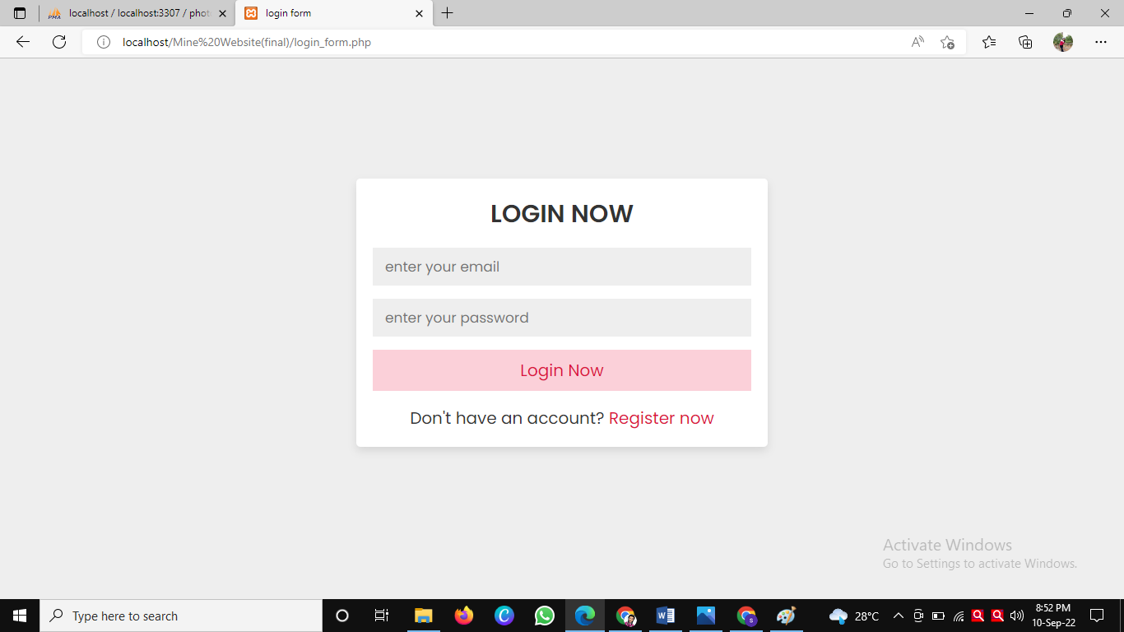

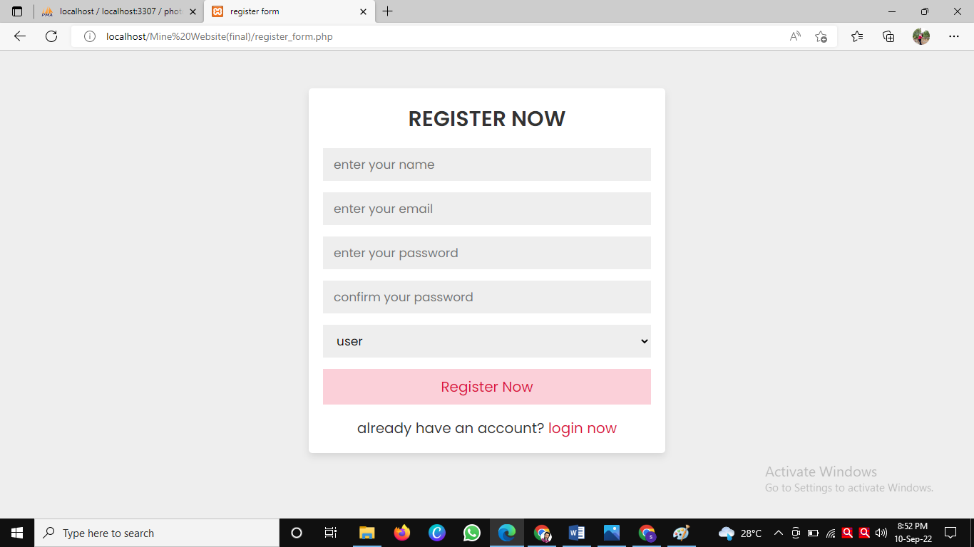

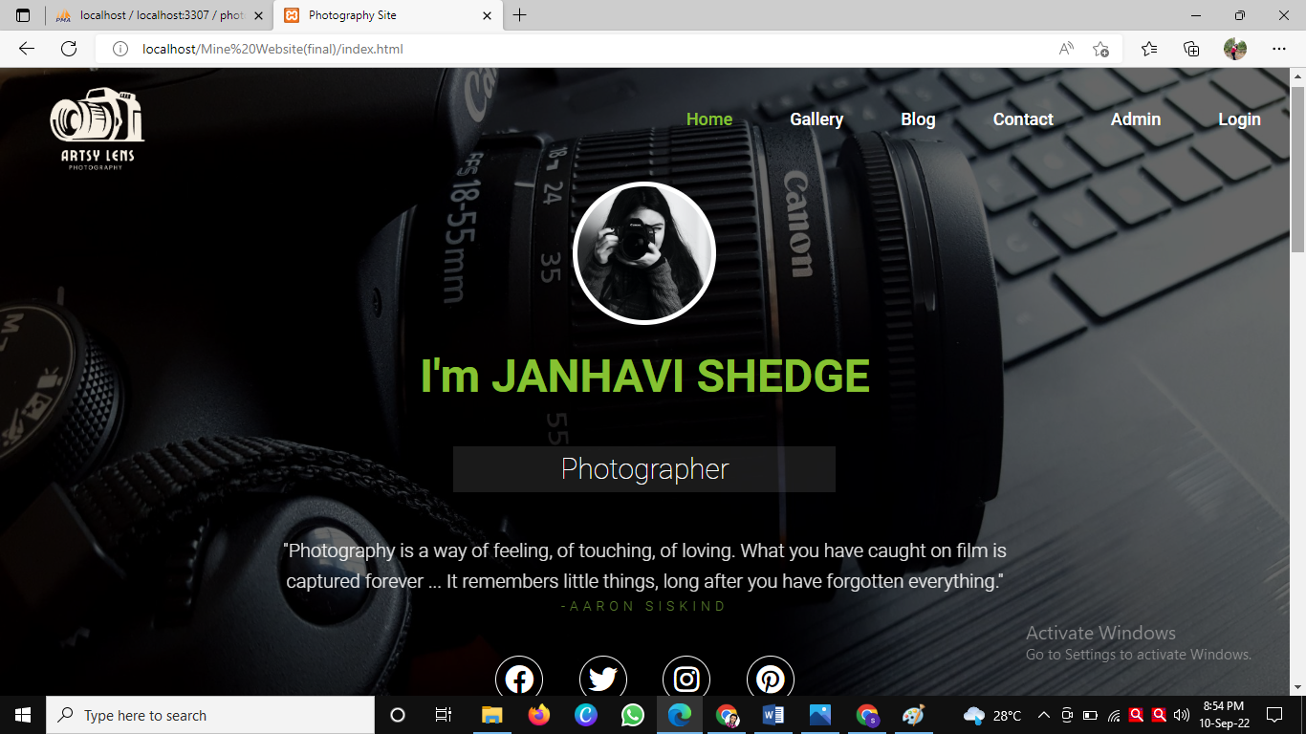

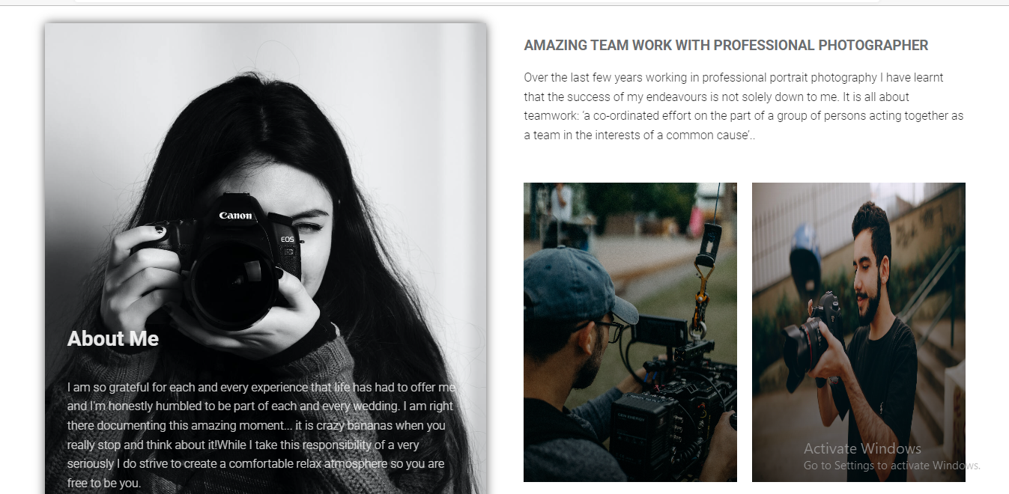

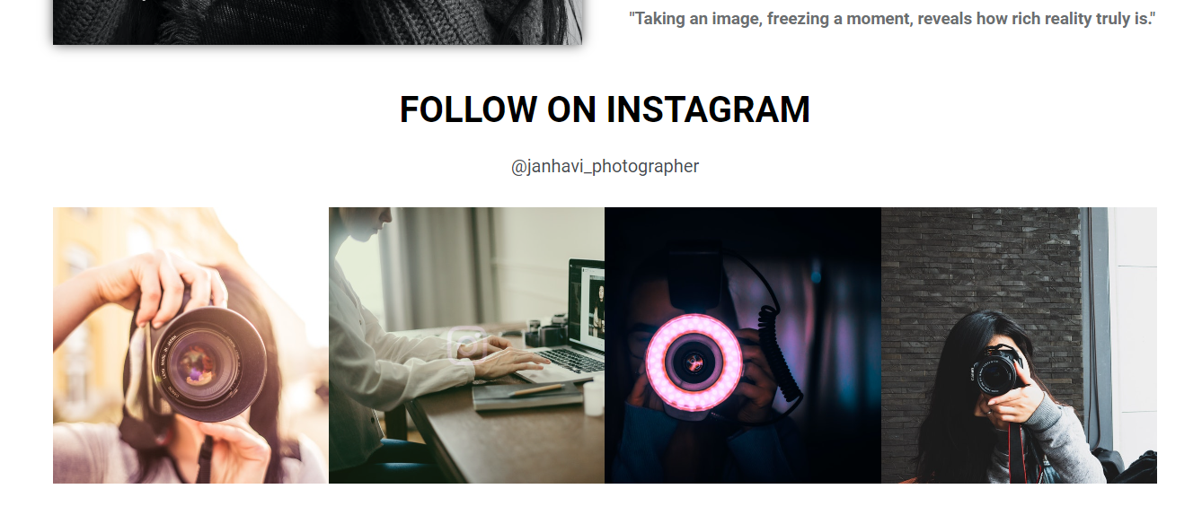



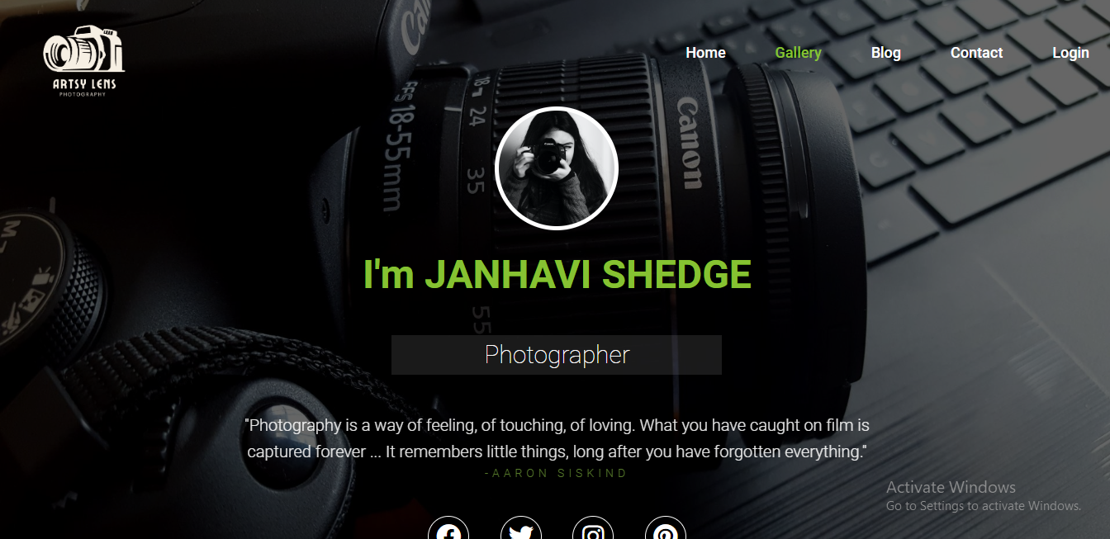

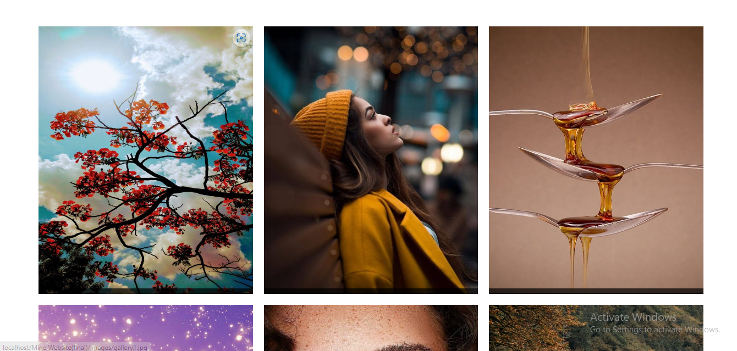

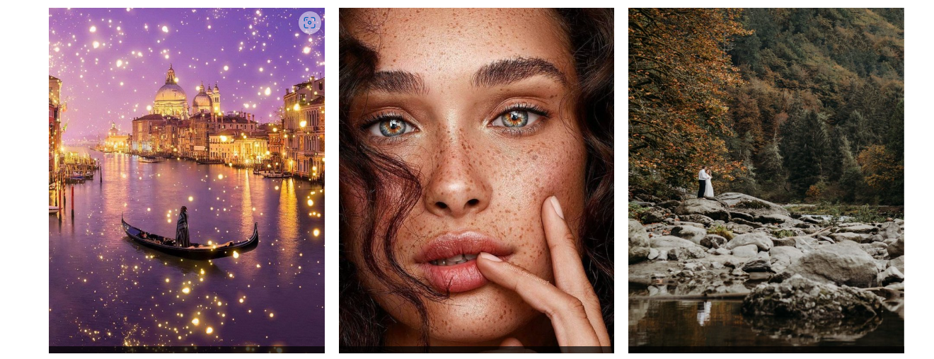

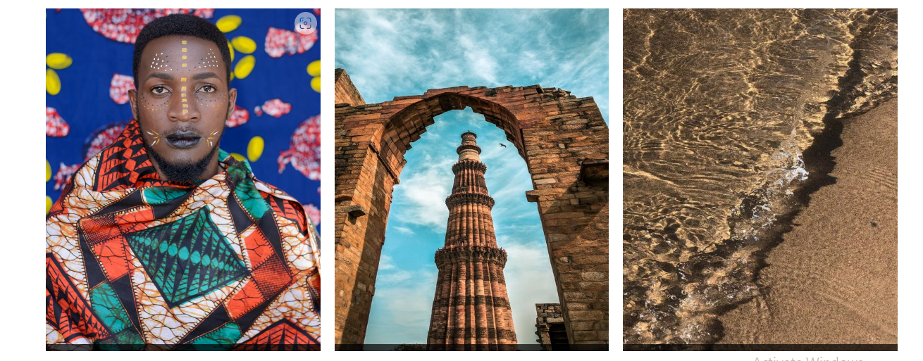

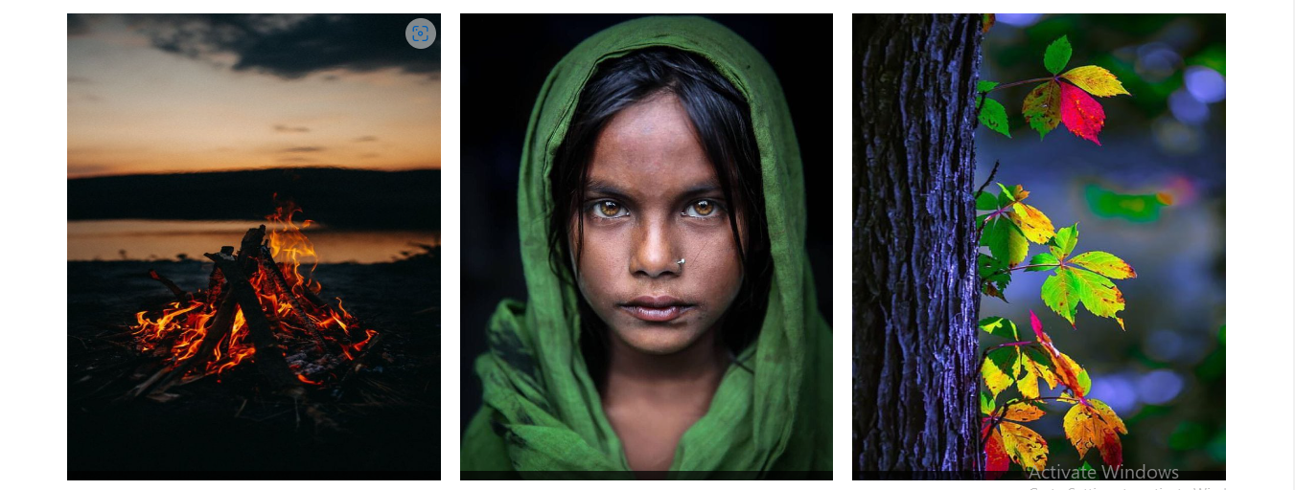



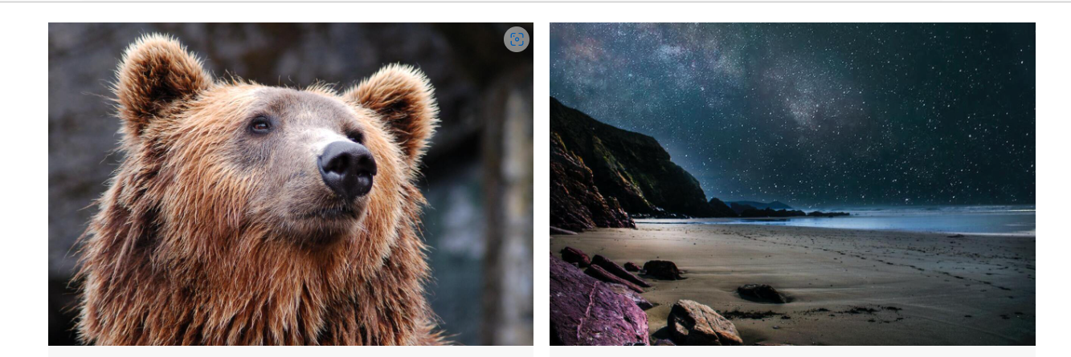

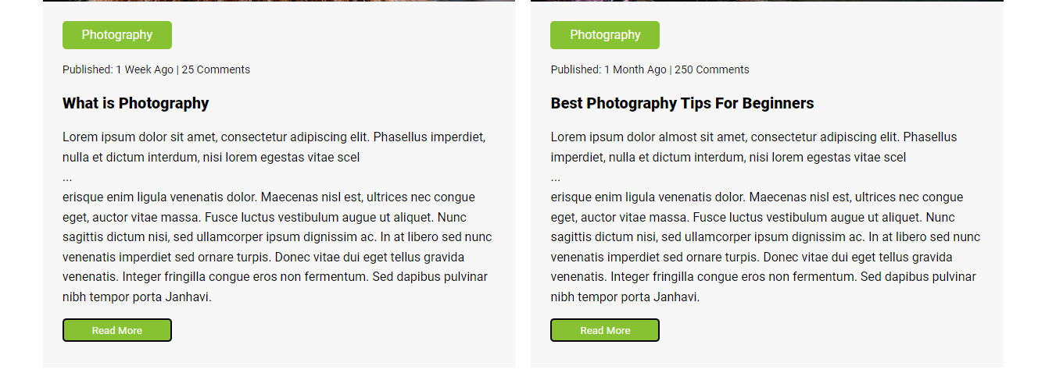

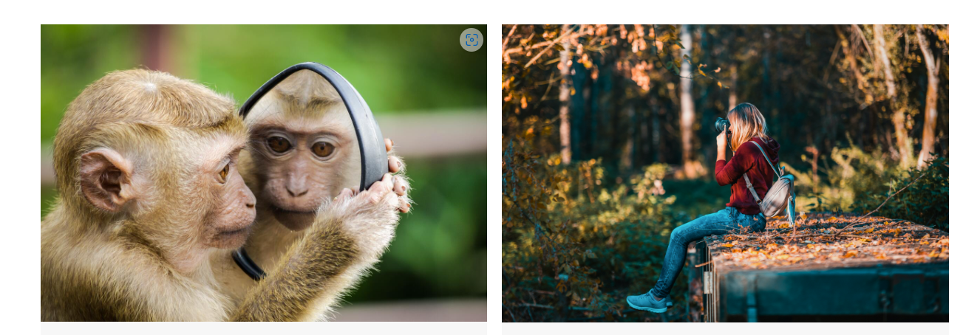

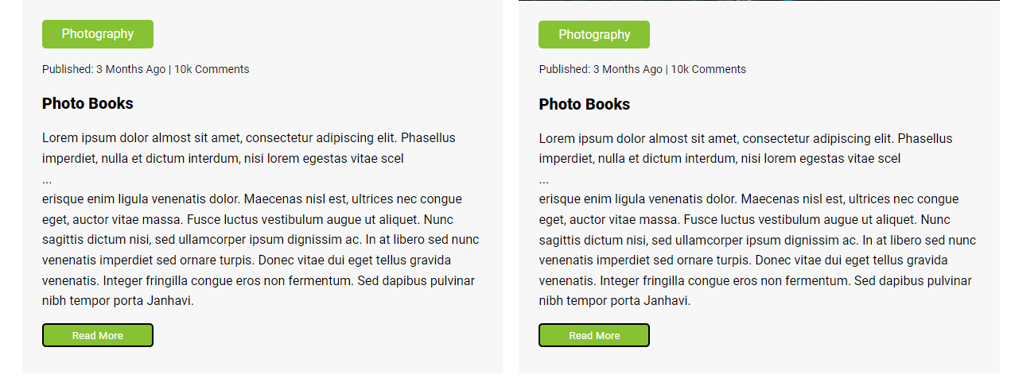

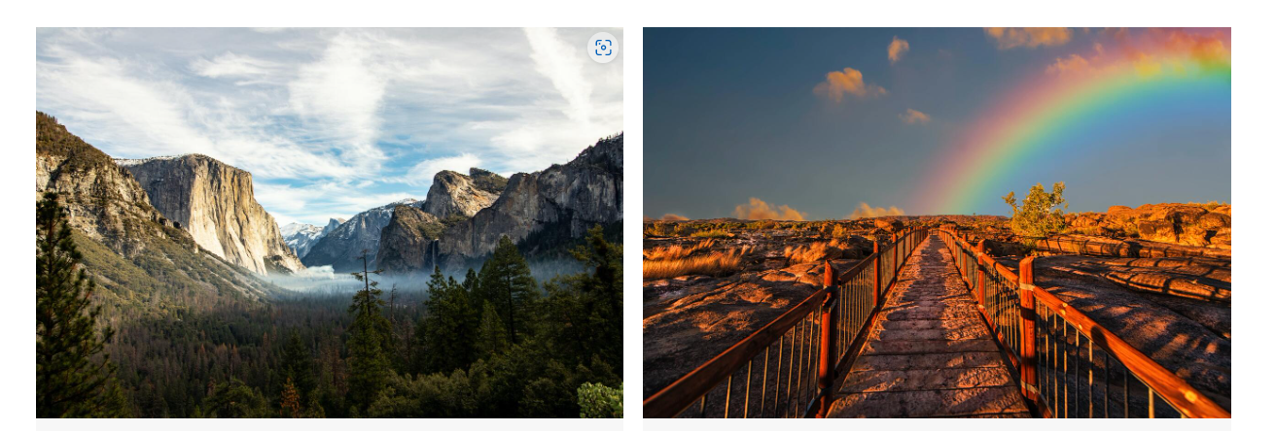

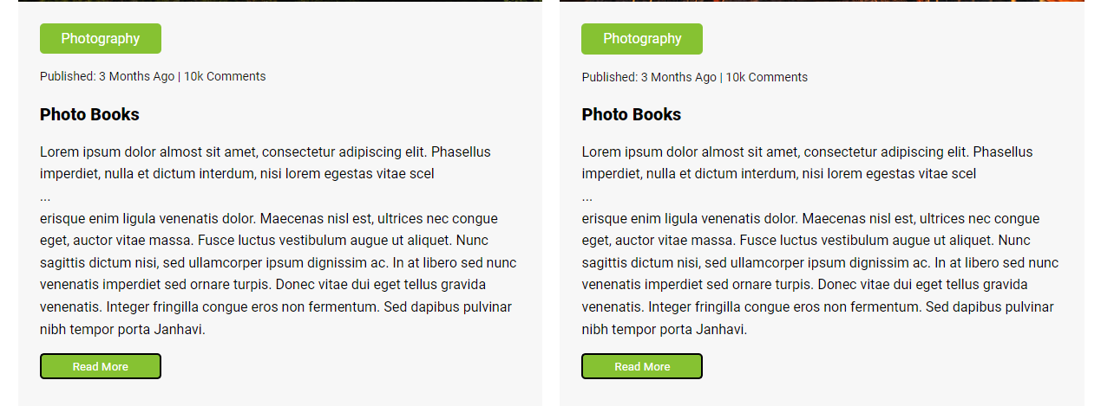



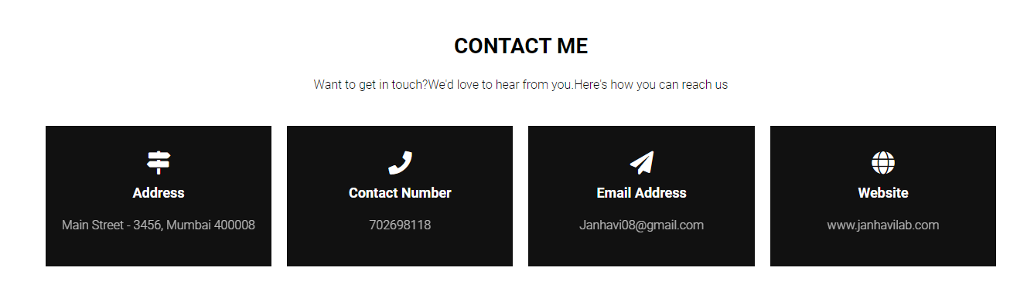

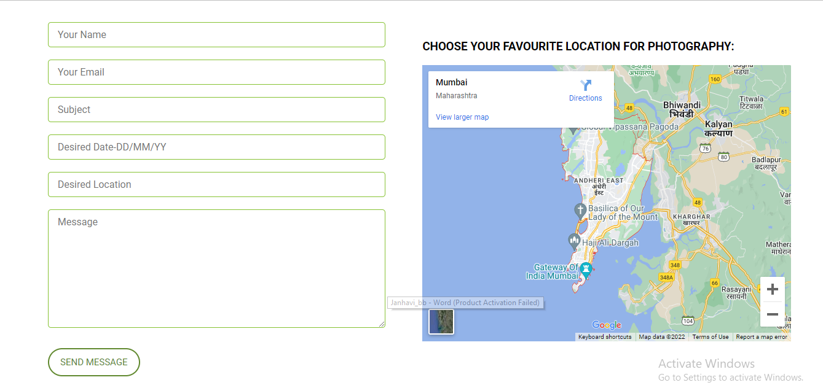



**-Admin panel**

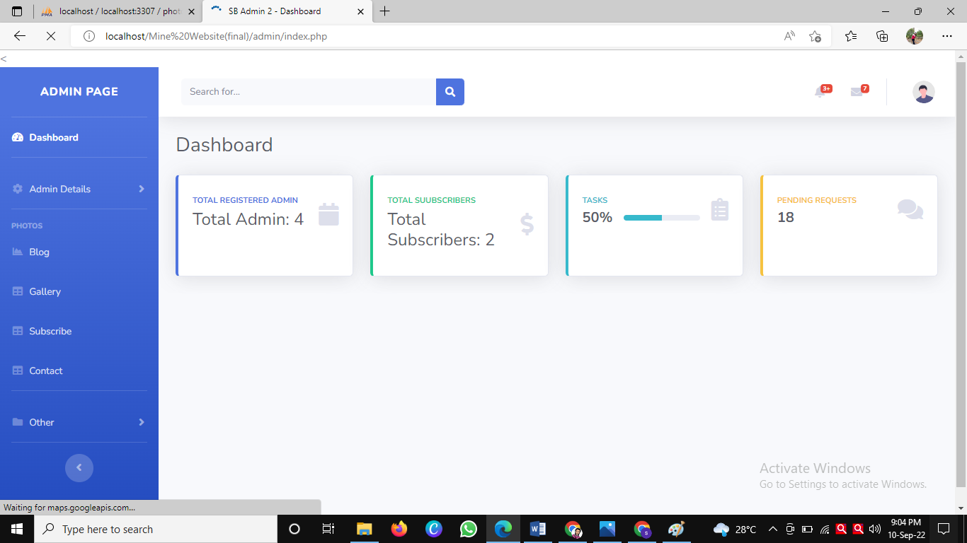

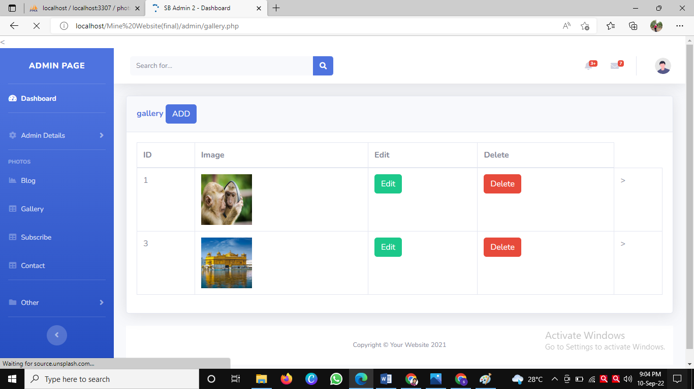

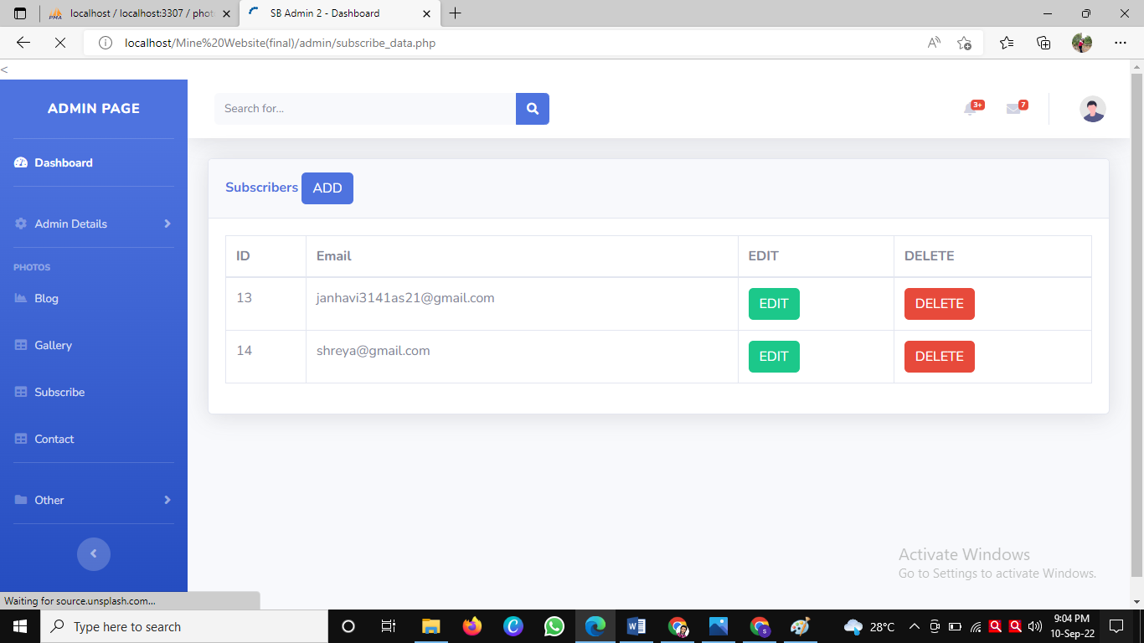

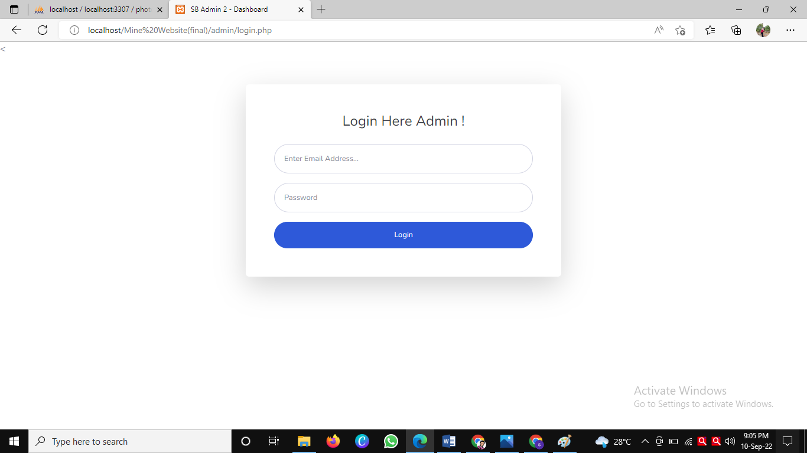

**7.Conclusion and future scope:**

**7.1 Future Enhancement:**

• Adding a better UI.

. Email verification.

•Hiring a photographer just by sitting at home all over the World

**7.2Conclusion:**

This Black book has been created with the objective of providing a systematic approach to Hire Photographers. The aim of the website is to provide shoe people photographher Work, and also to save the time of user.

The website will be free of cost and can be used when it meets the minimum system requirements of having a browser and then the user can search for various Photographers Hiring.

**8.References**

**•https://www.google.com**

**•https://www.youtube.com**

**•https://www.wikipedia.org**

**•https://stackoverflow.com/**

**9.Annexure:**

**9.Annexure:**

**Figures list:**

|  |  |  |
| --- | --- | --- |
| Serial Number | Name of figure | Page number |
| 4.2 | Class Diagram | 5 |
| 4.3 | Use Case Diagram | 5 |
| 4.4 | Sequence Diagram | 6 |
| 4.5.1 | Activity diagram | 7 |
| 4.6.1 | State diagram for admin | 7 |
| 4.6.2 | State diagram for user | 8 |
| 4.7 | Package Diagram | 8 |
| 4.8 | Component Diagram | 9 |
| 4.9 | Deplyoment Diagram | 9 |

**Table List:**

|  |  |  |
| --- | --- | --- |
| Table number | Name of Table | Page Number |
| 4.1 | Event table | 4 |
| 4.10.1 | Database Design for subscribe | 10 |
| 4.10.2 | Database Design for gallery | 10 |
| 4.10.3 | Database Design for register | 10 |
| 4.10.4 | Database design for user_form | 10 |
| 6.1 | Validation and Naming conventions | 55 |